**Auto scaling Group**

Launch EC2 instance

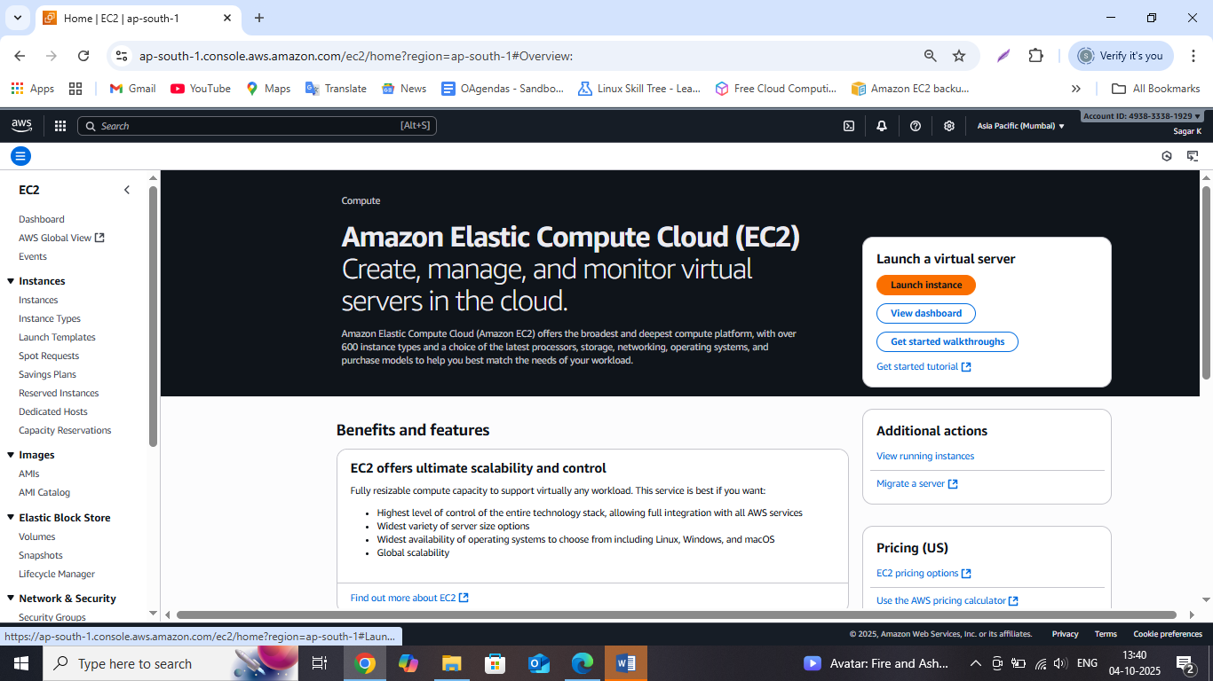

Name your server and select the OS image as Ubuntu

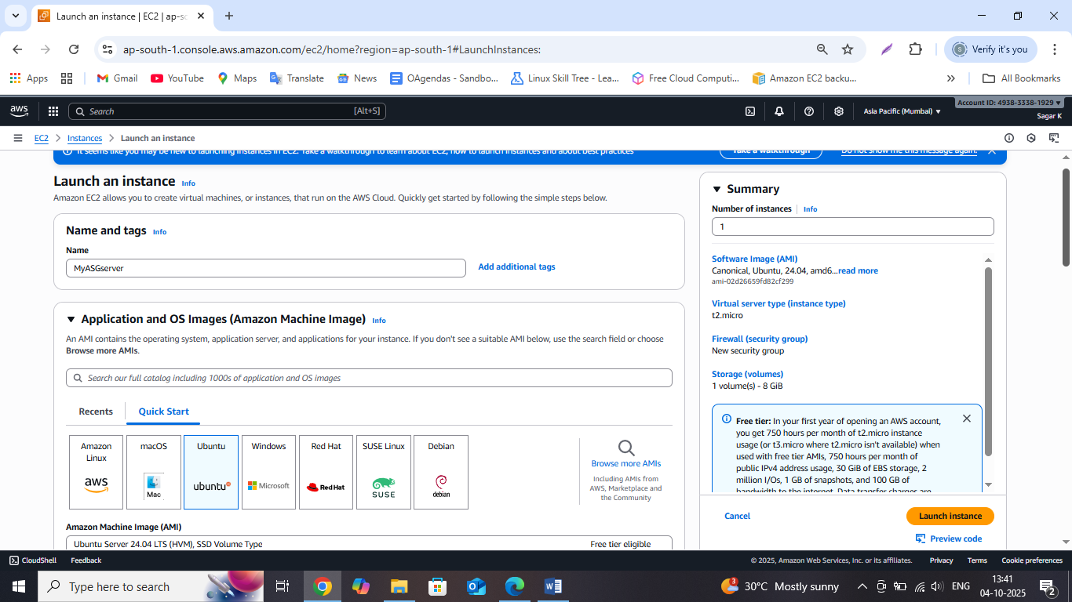

Select a Free eligible tier AMI and Instance type

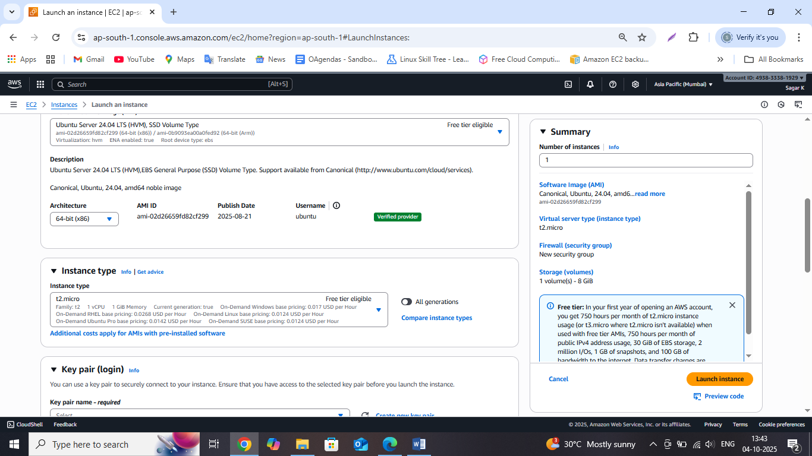

Create a new Key Pair

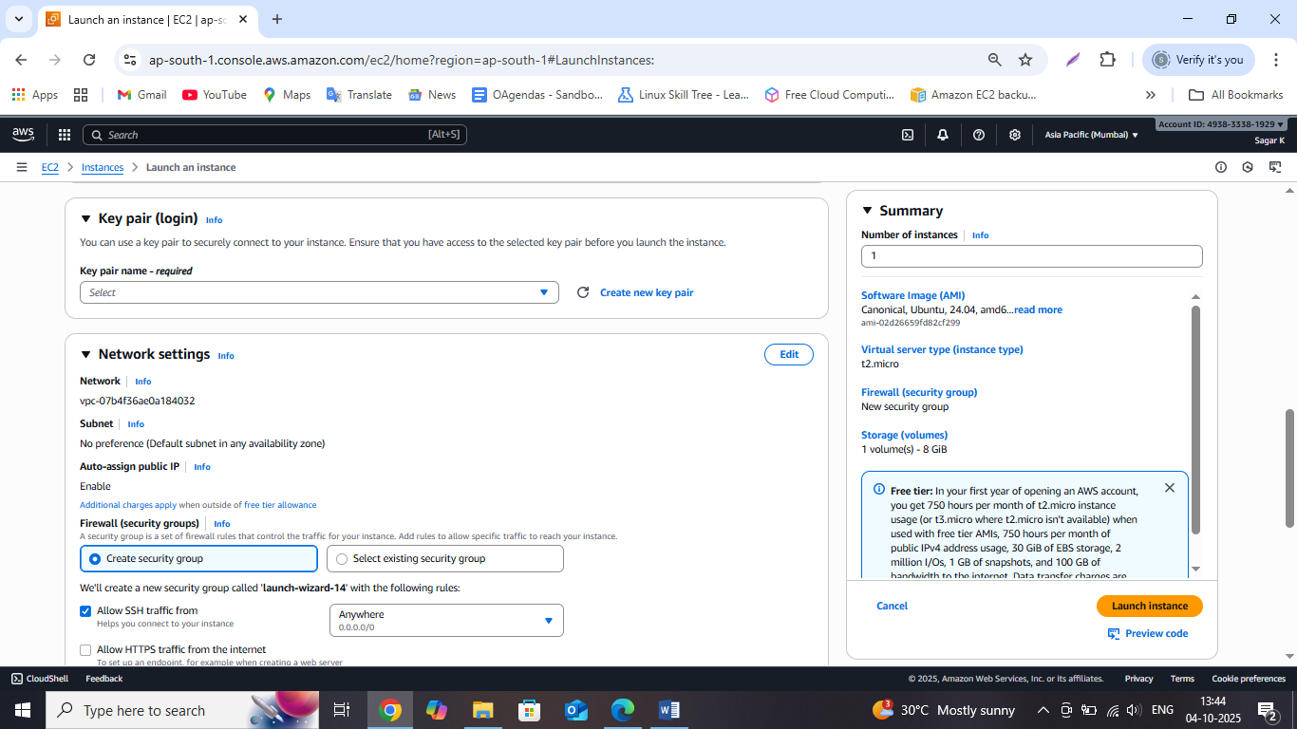

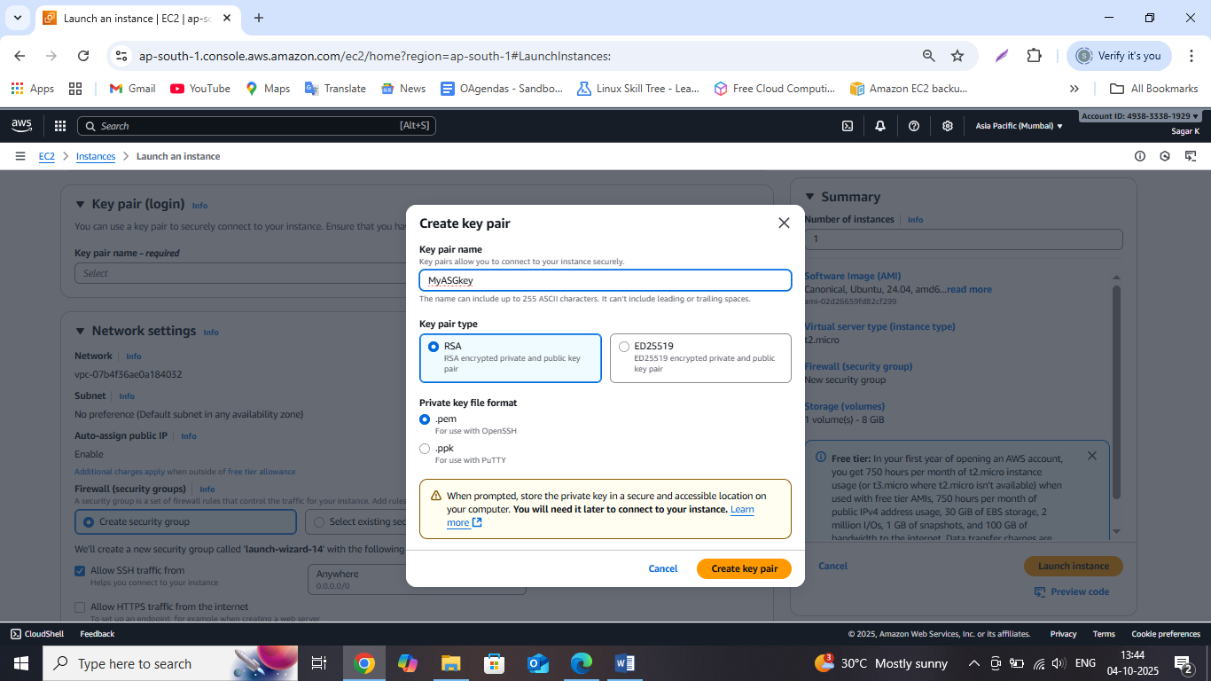

Create the security Group and select the Allow Http Traffic from the Internet checkbox

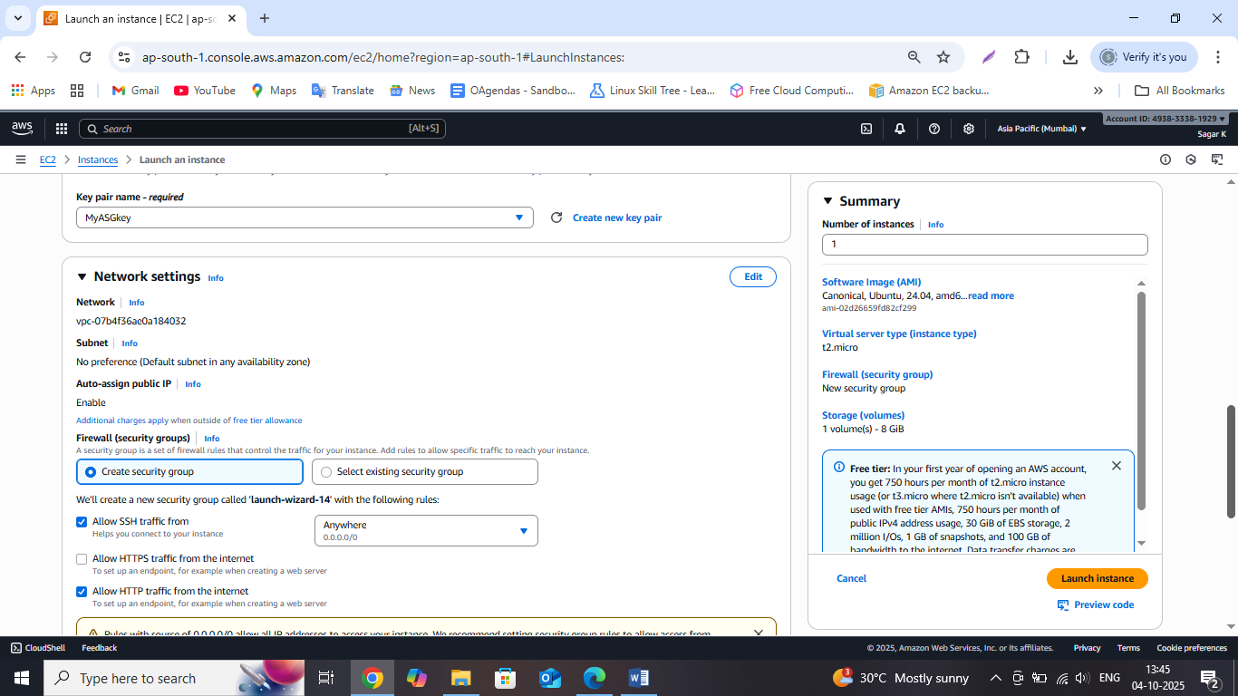

Go to Advance Details and enter the commands to install Apache2 and also enter the commands to create our index.html page.

The advance details commands install the software in our instance rather than we connecting the EC2 instance and entering the commands one by one

/var/www/hmtl is the path where apache2 index.html default page is install we need to replace that with our new content

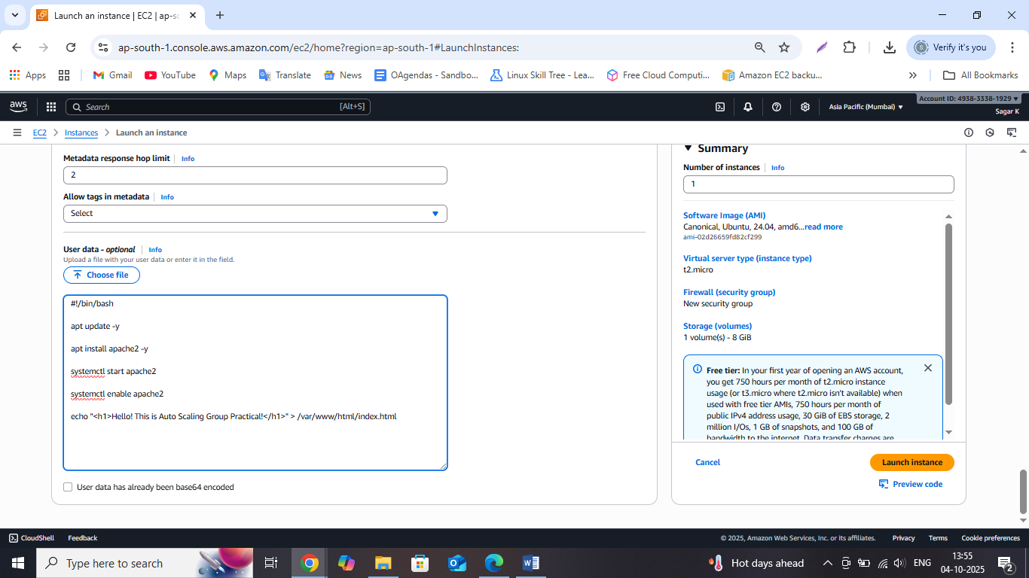

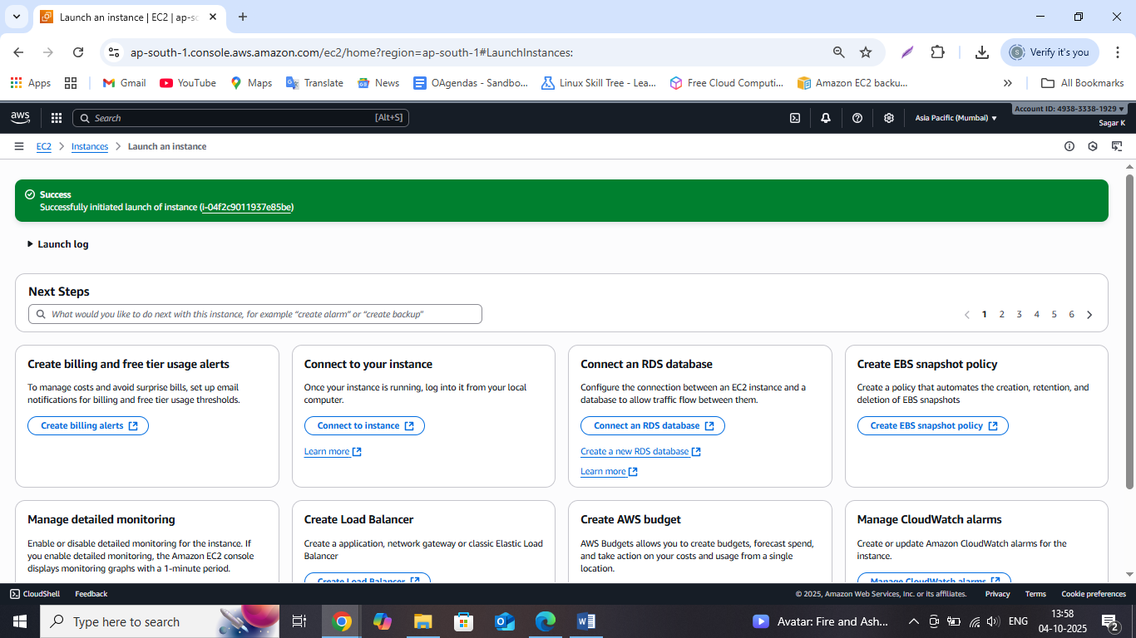

Go to Instances and check if the **instance state is running** and **status check is passed**

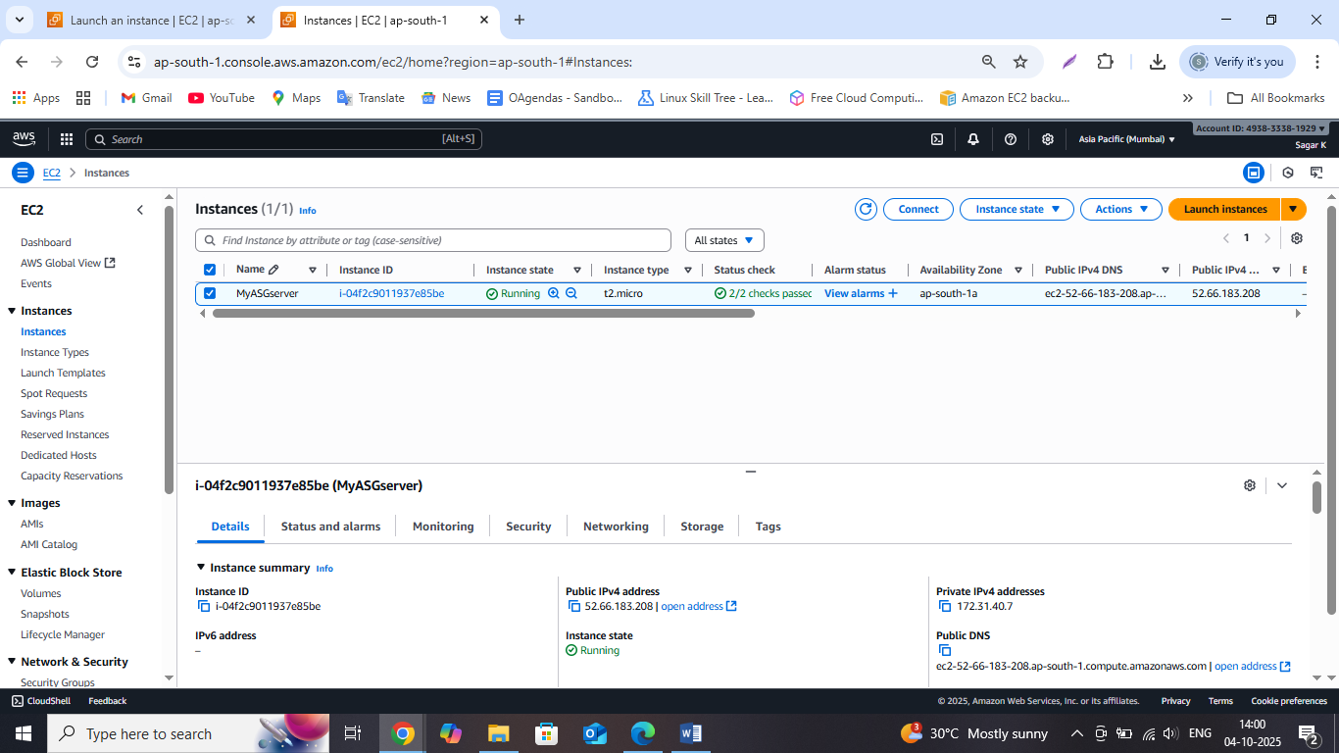

Now copy the Public address and enter the same in new tab to check if our apache2 server is installed properly and our web page is created

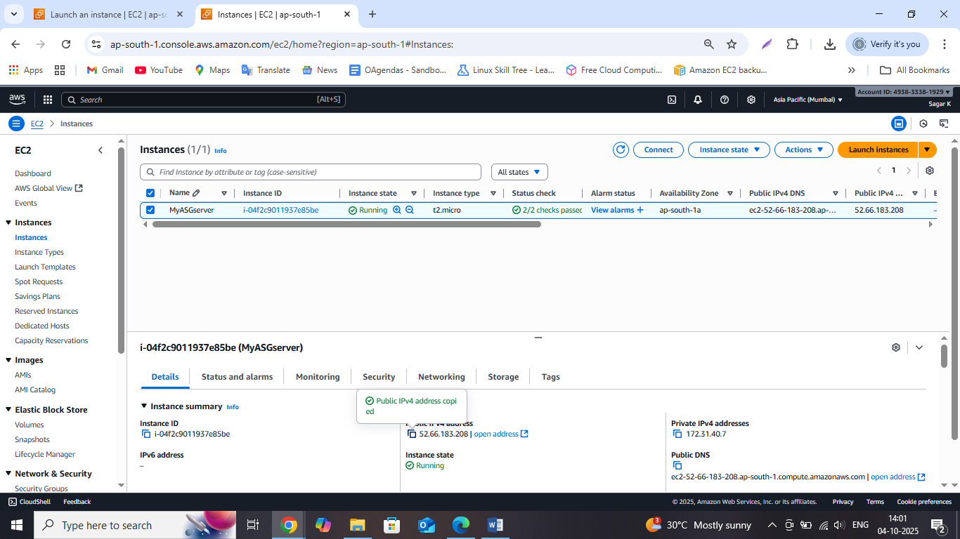

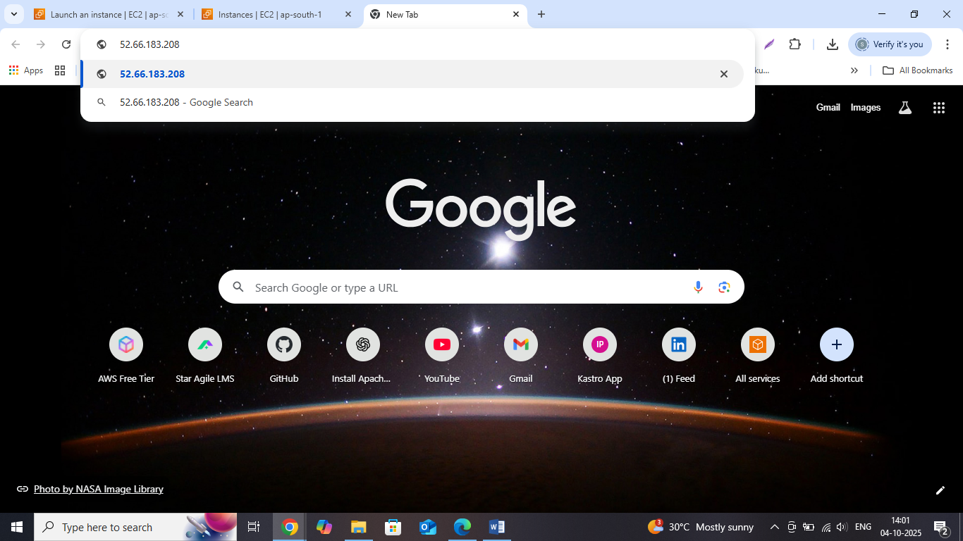

As you can see in the below screenshot, we are getting the same content which we had used while creating index.html page through user data of EC2 instance.

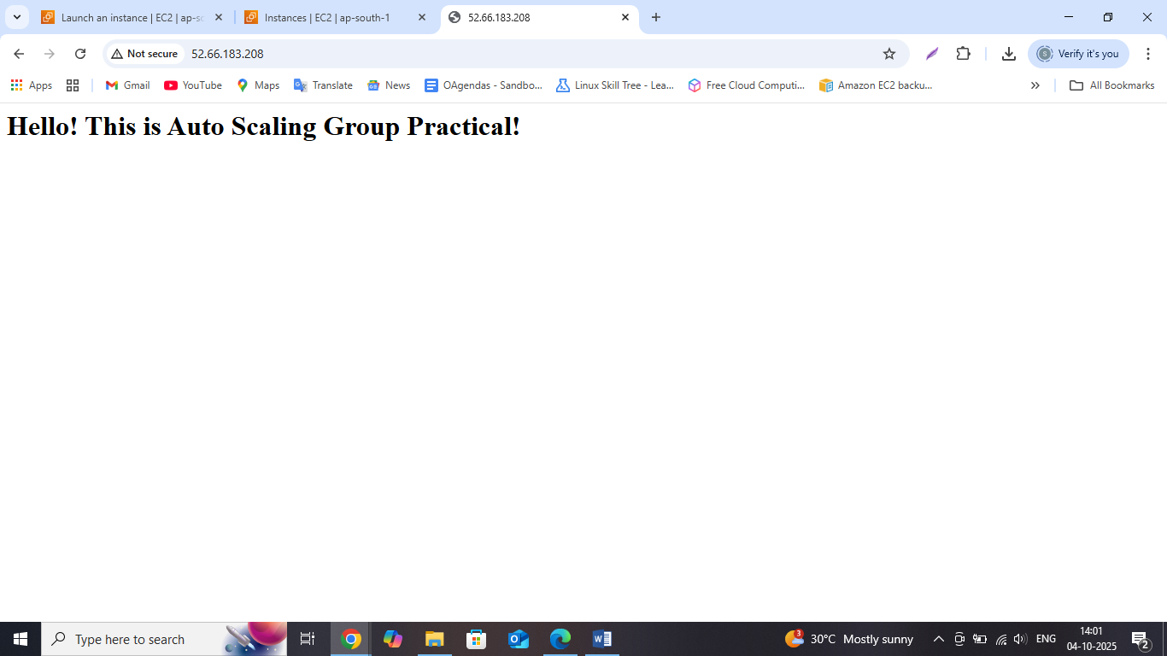

Now we will create the Snapshot using the EC2 instance

It is always recommended to stop the EC2 instance before creating a snap shot

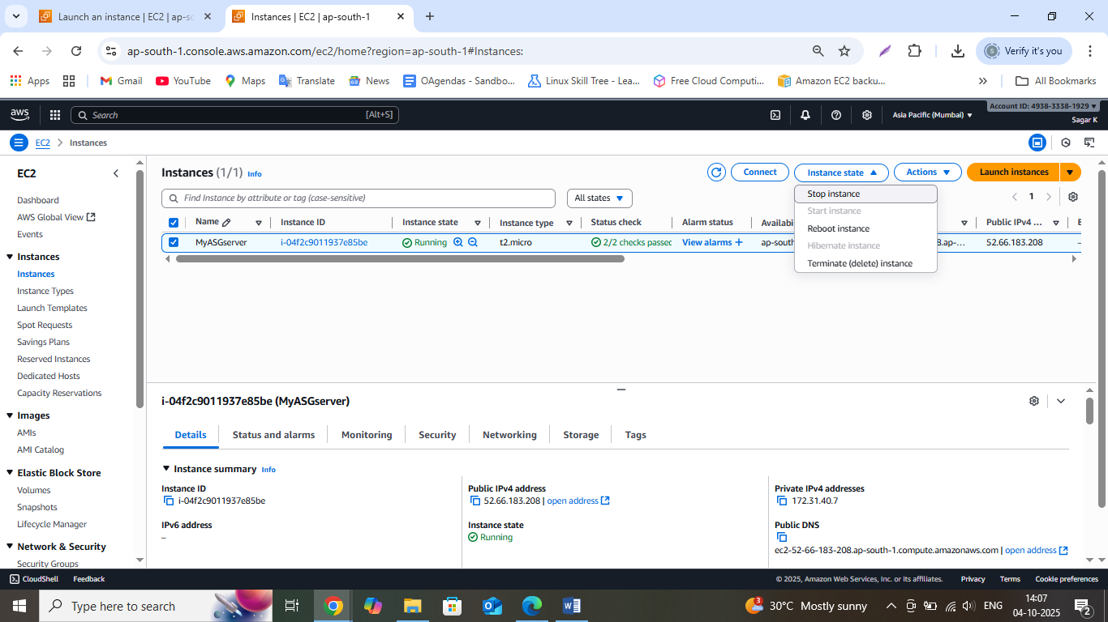

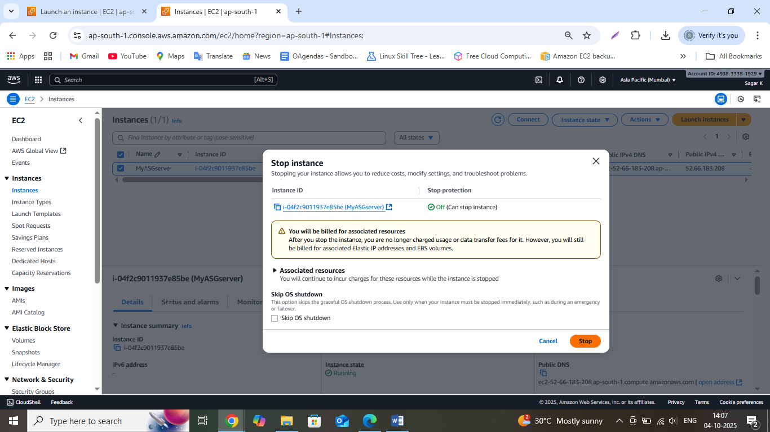

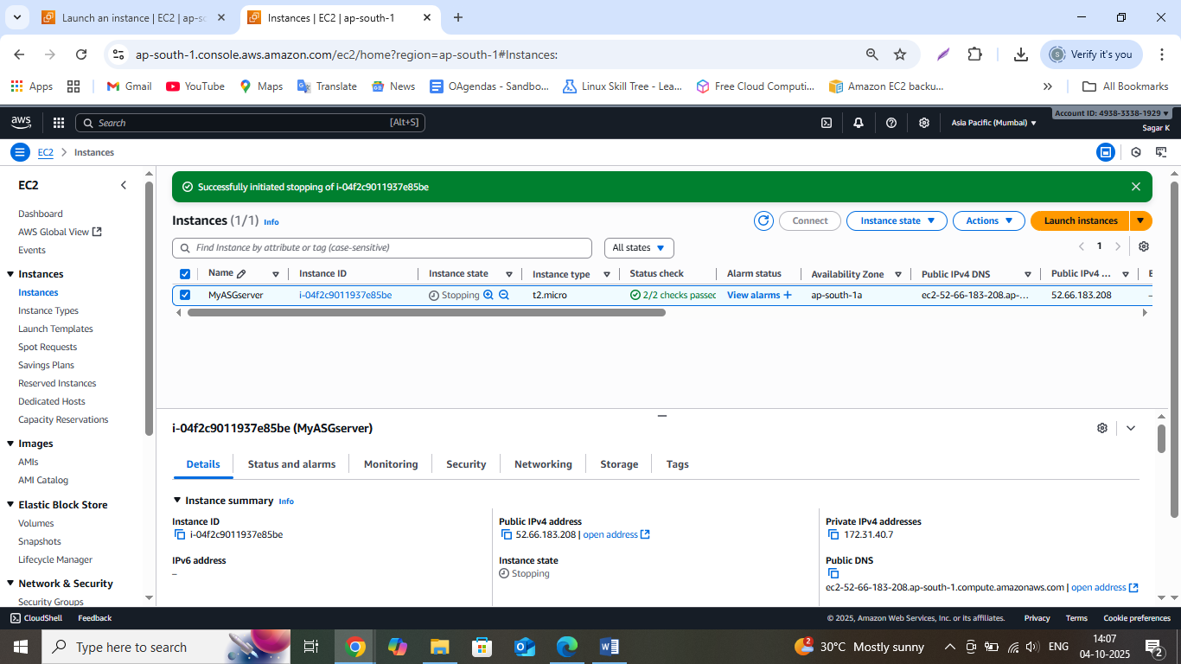

Under Elastic Block Storage> select Snapshots

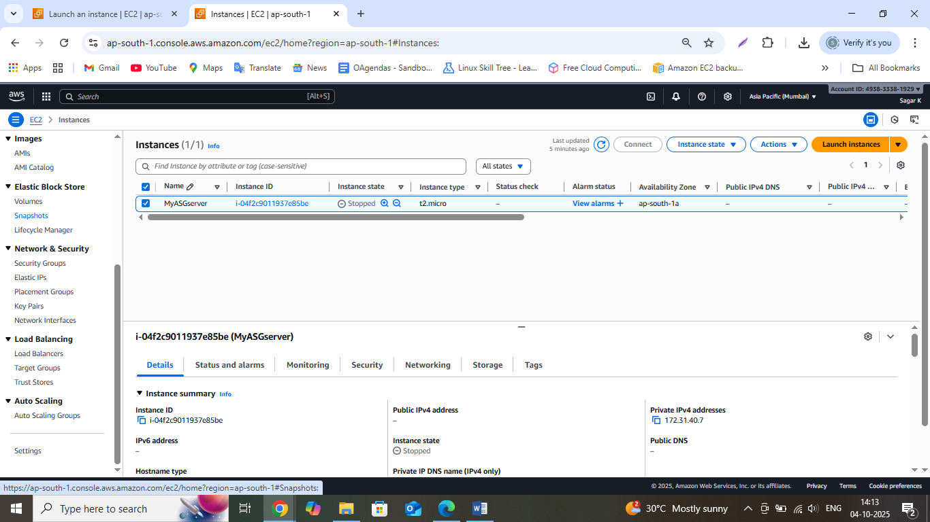

Click on Create Snapshot

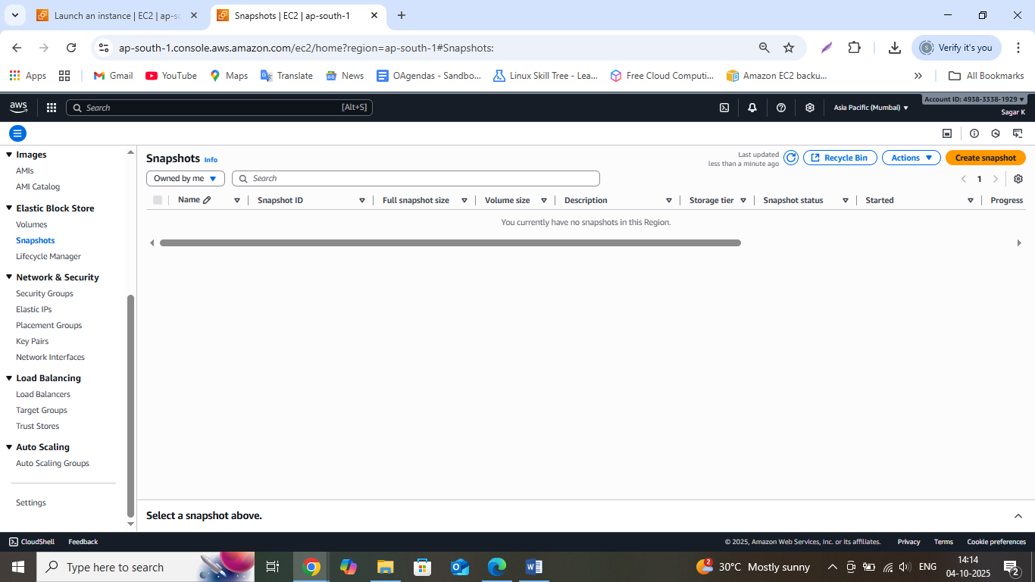

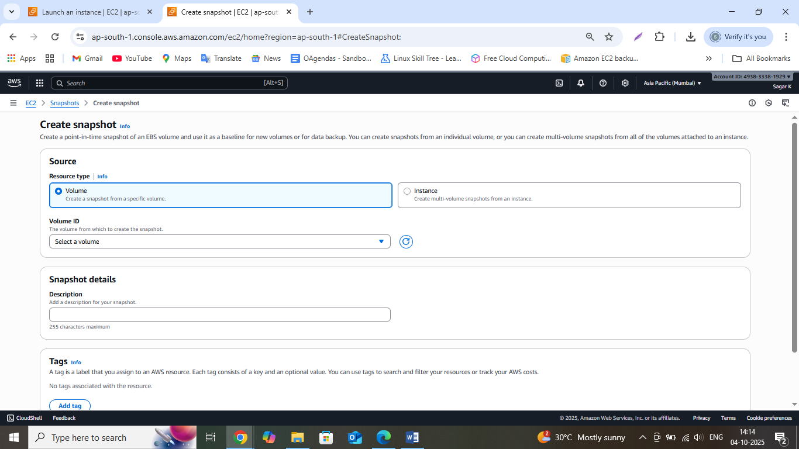

Select the instance and select the EC2 instance which we created

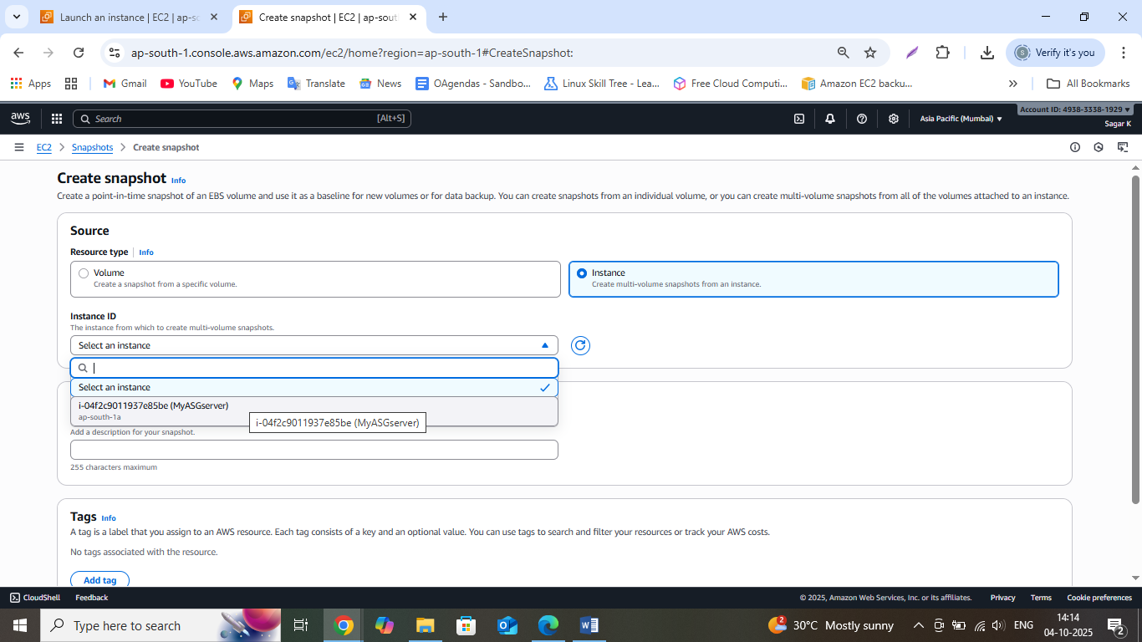

Enter snapshot description and Click on Create Snapshot

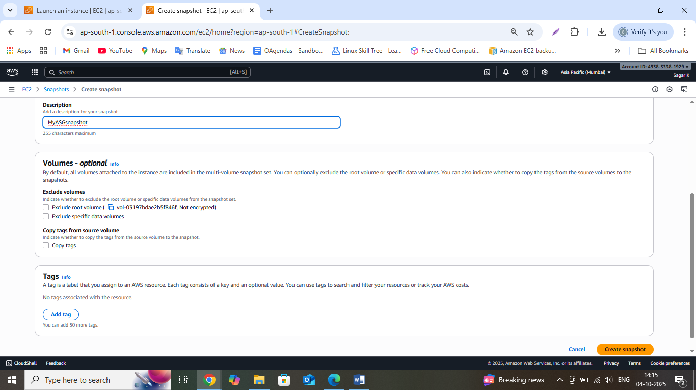

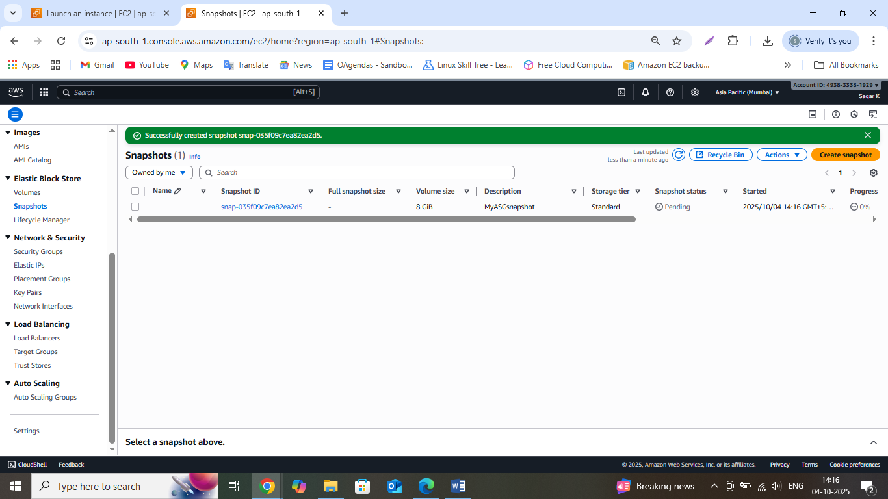

Wait for the snapshot status to change from pending to completed

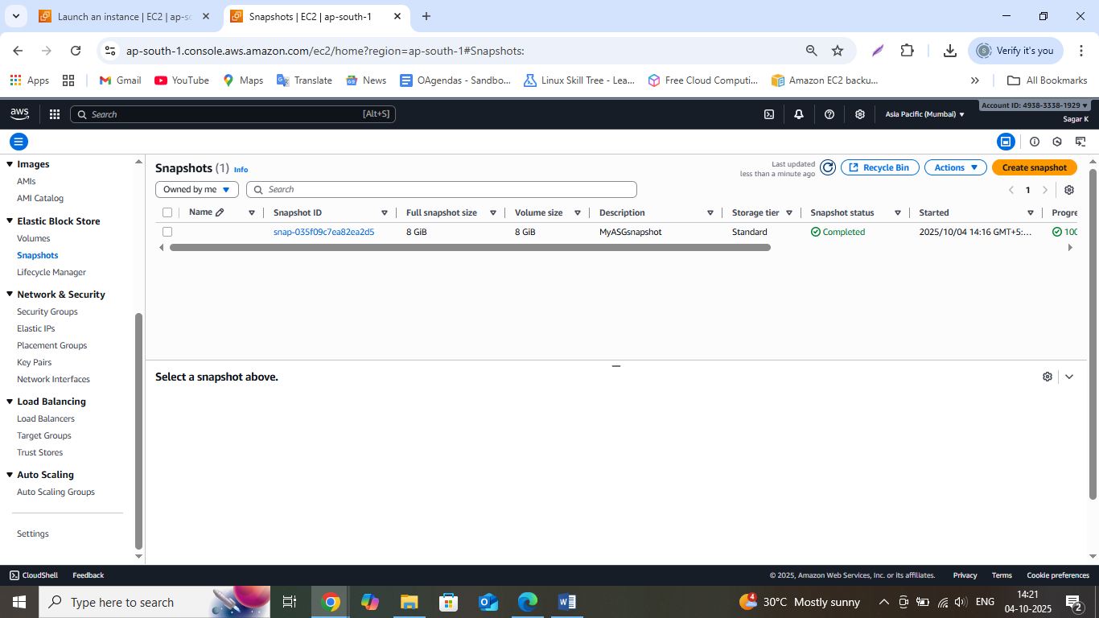

Once the status is completed select the Snapshot checkbox and click on actions and select Create Image from Snapshot

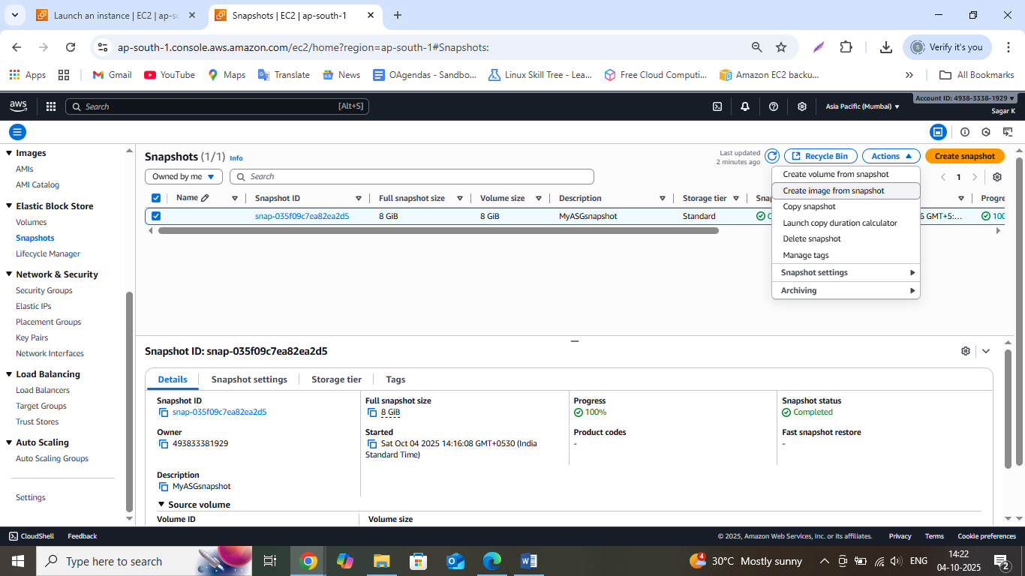

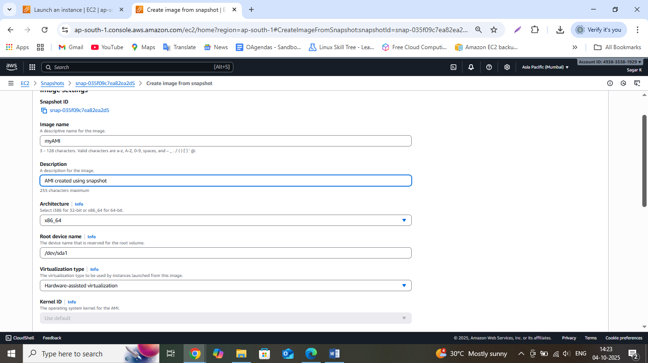

Click on Create Image

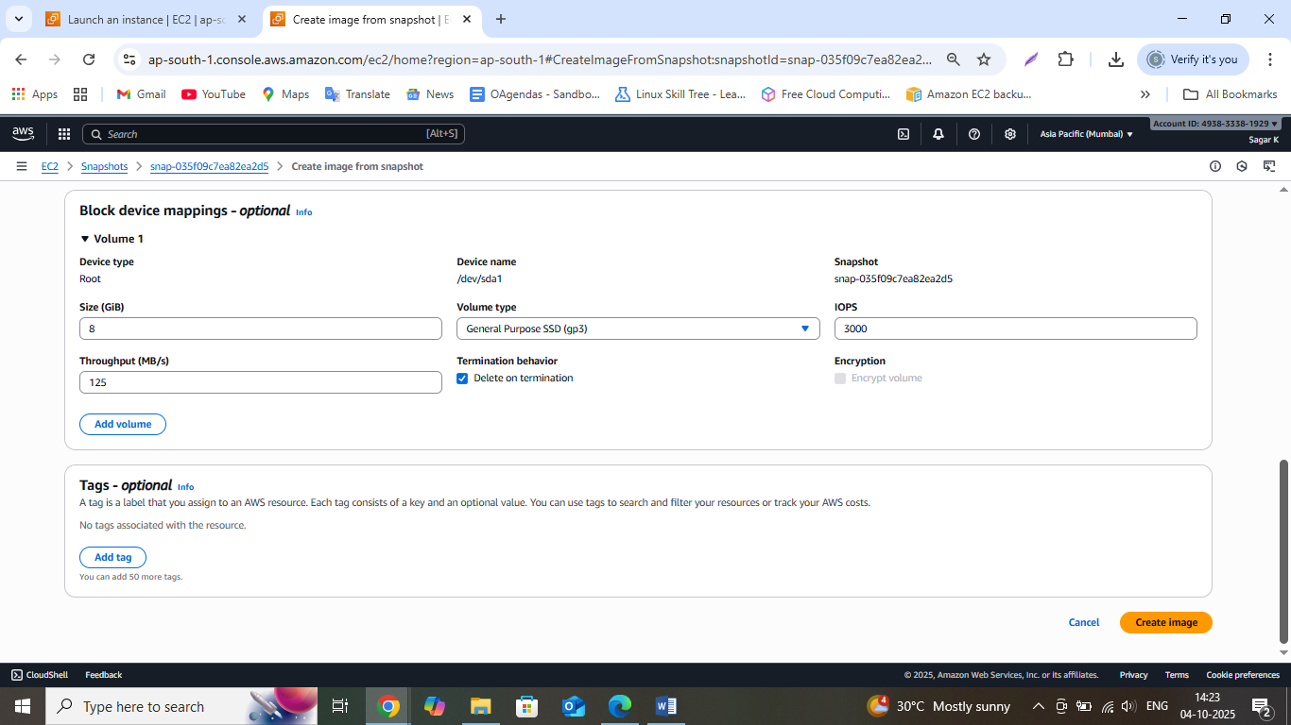

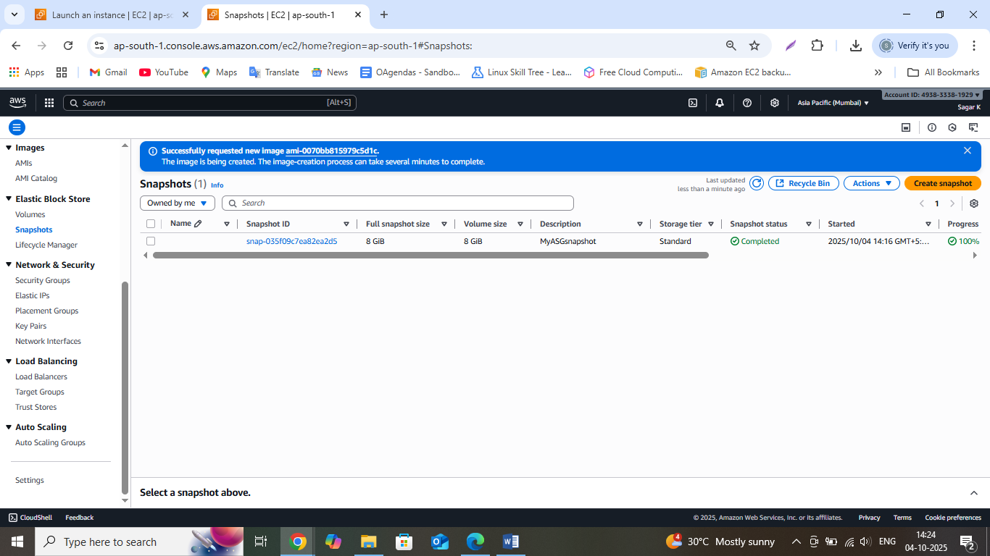

Go to AMI under Images and check if the AMI is successfully created

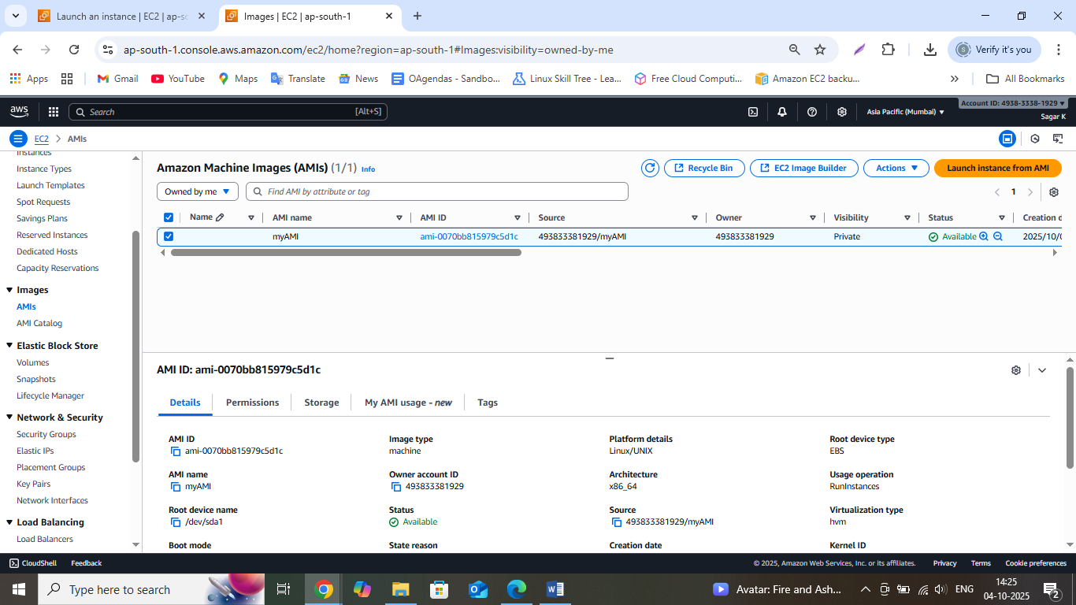

Now go to Instances> Launch Template, The Launch Template Created will be Utilized for Creating a new machine via auto scaling

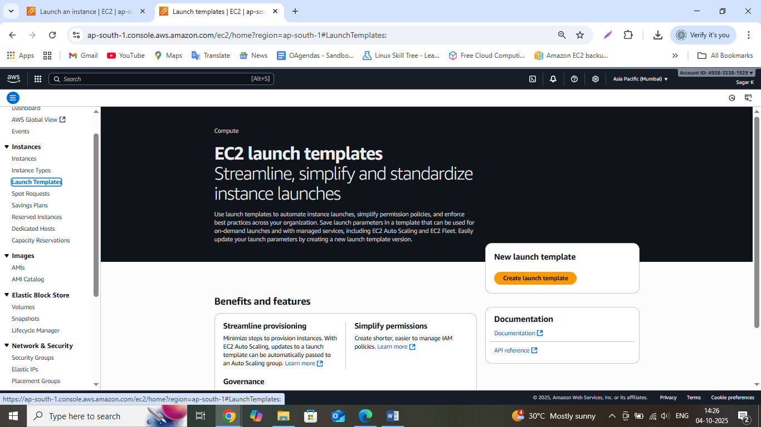

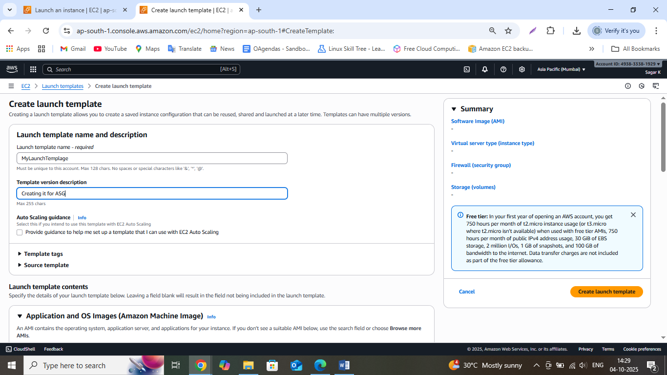

Go application OS and Images> select the My AMIs tab and select the AMI created by us using snapshot

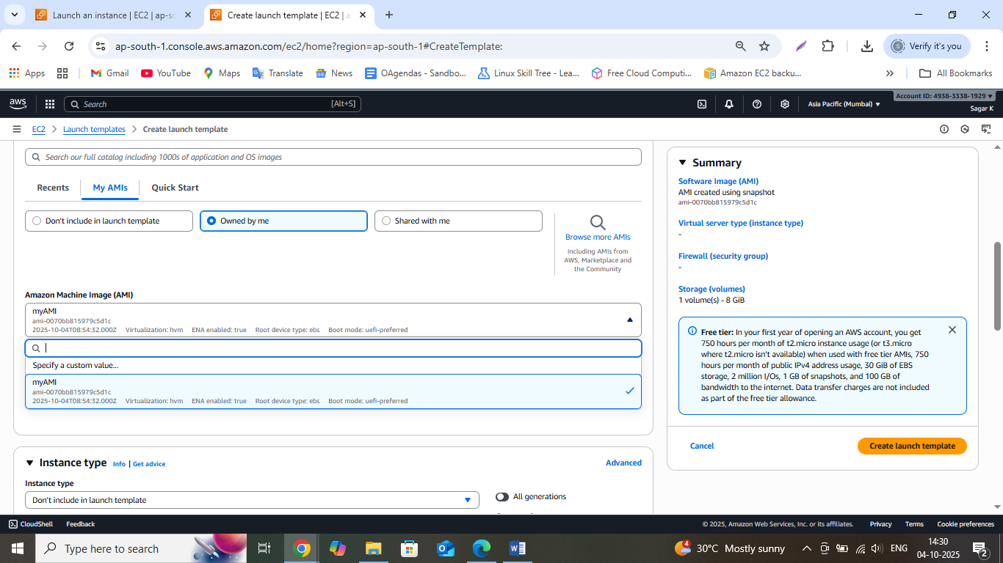

Select the instance type as t2.micro. Select the Key Pair created by us earlier or you can also create a new one

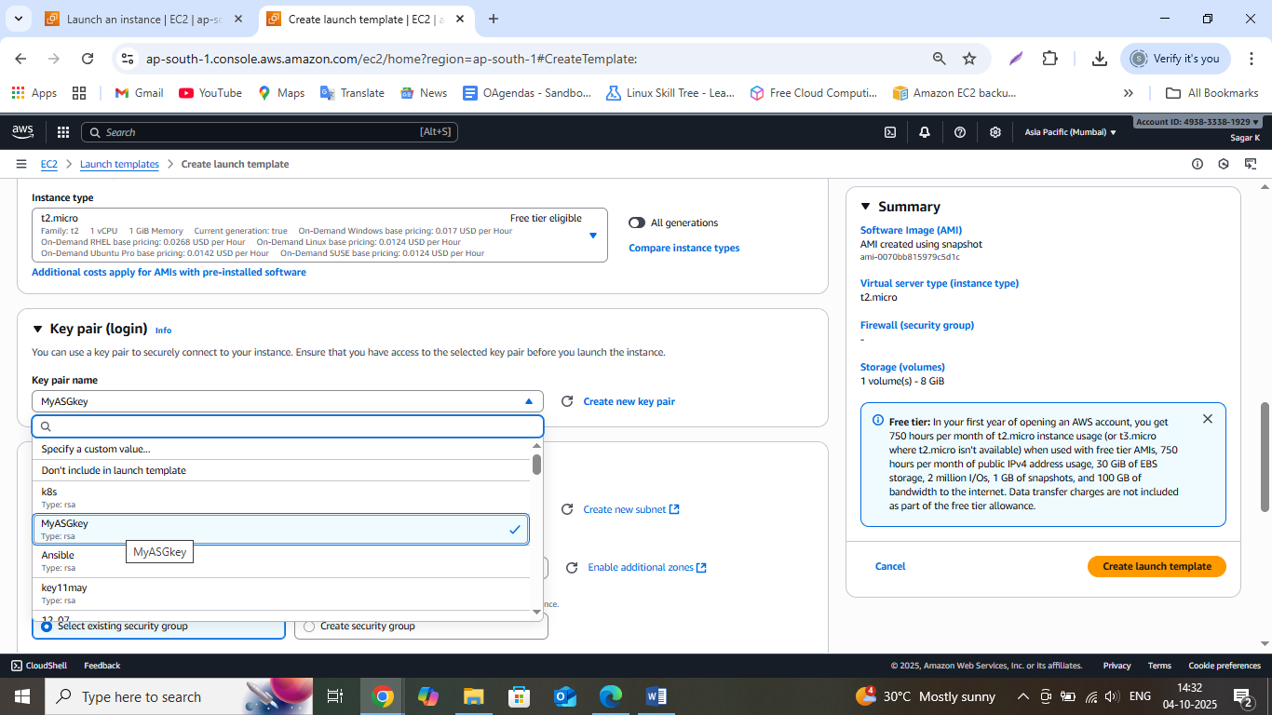

Select the existing security group or you can create a new one

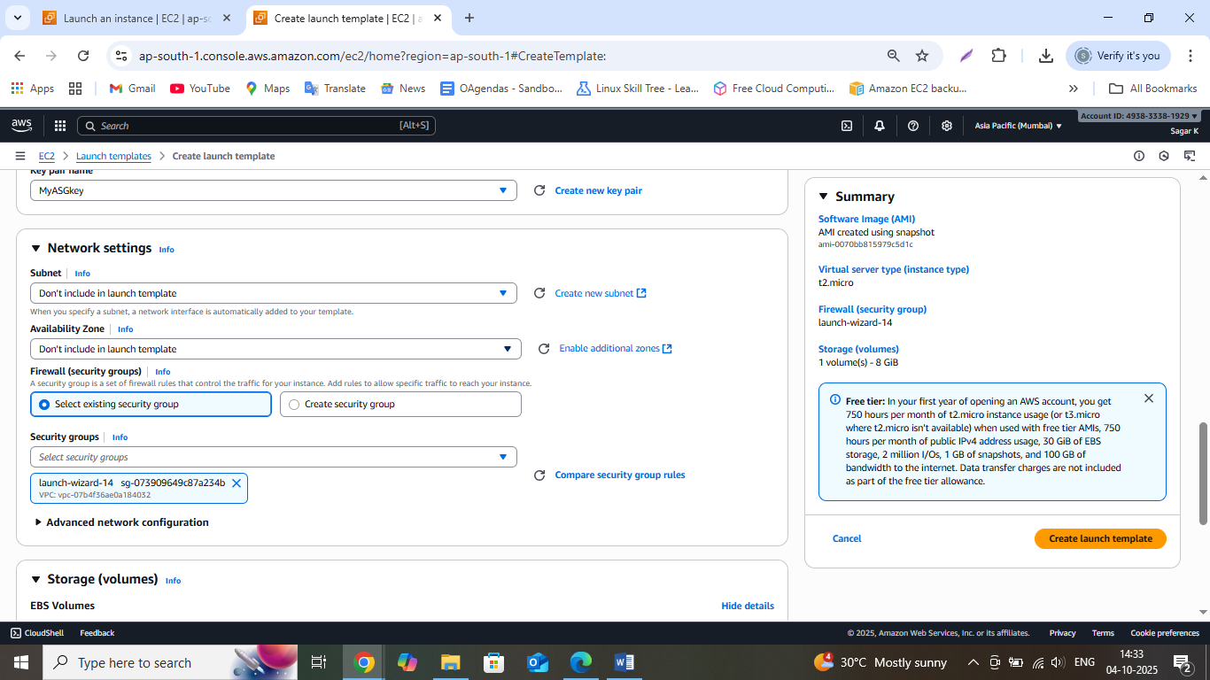

Add user data so that whenever EC2 instance is created using the below template in Auto scaling it will have apache2 preinstalled in the instance created

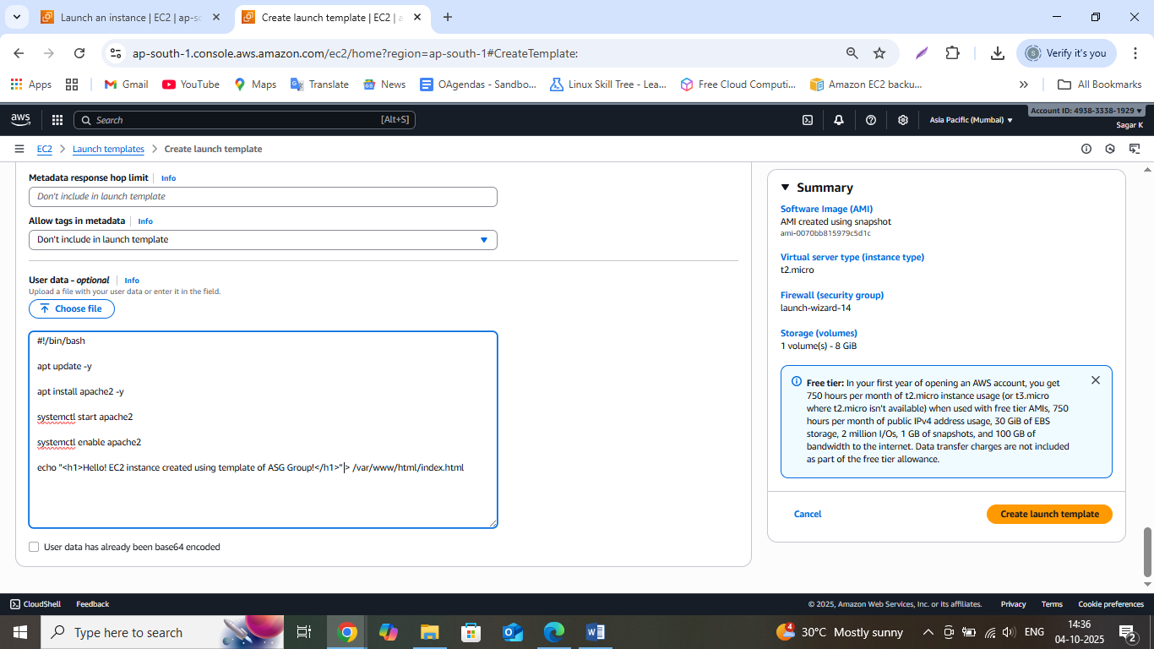

Click on Create Launch Template

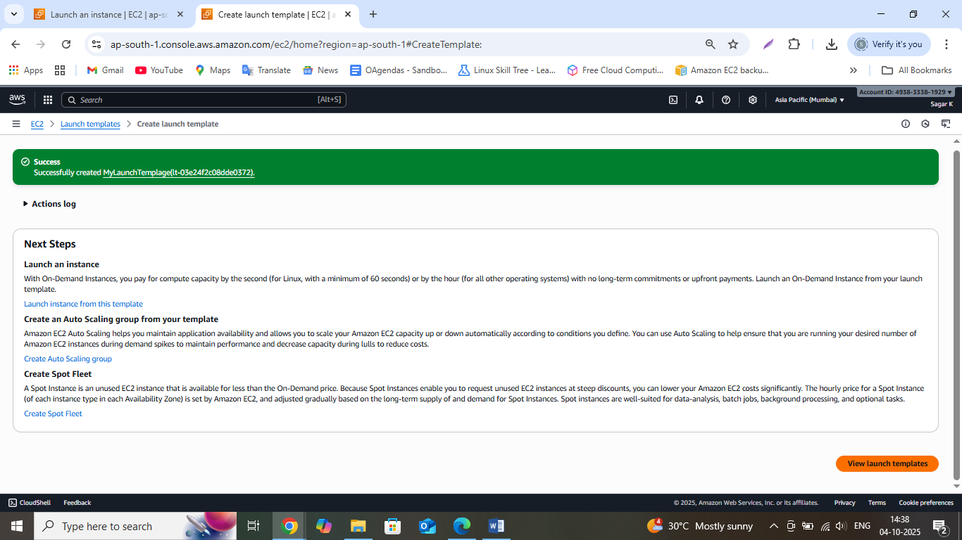

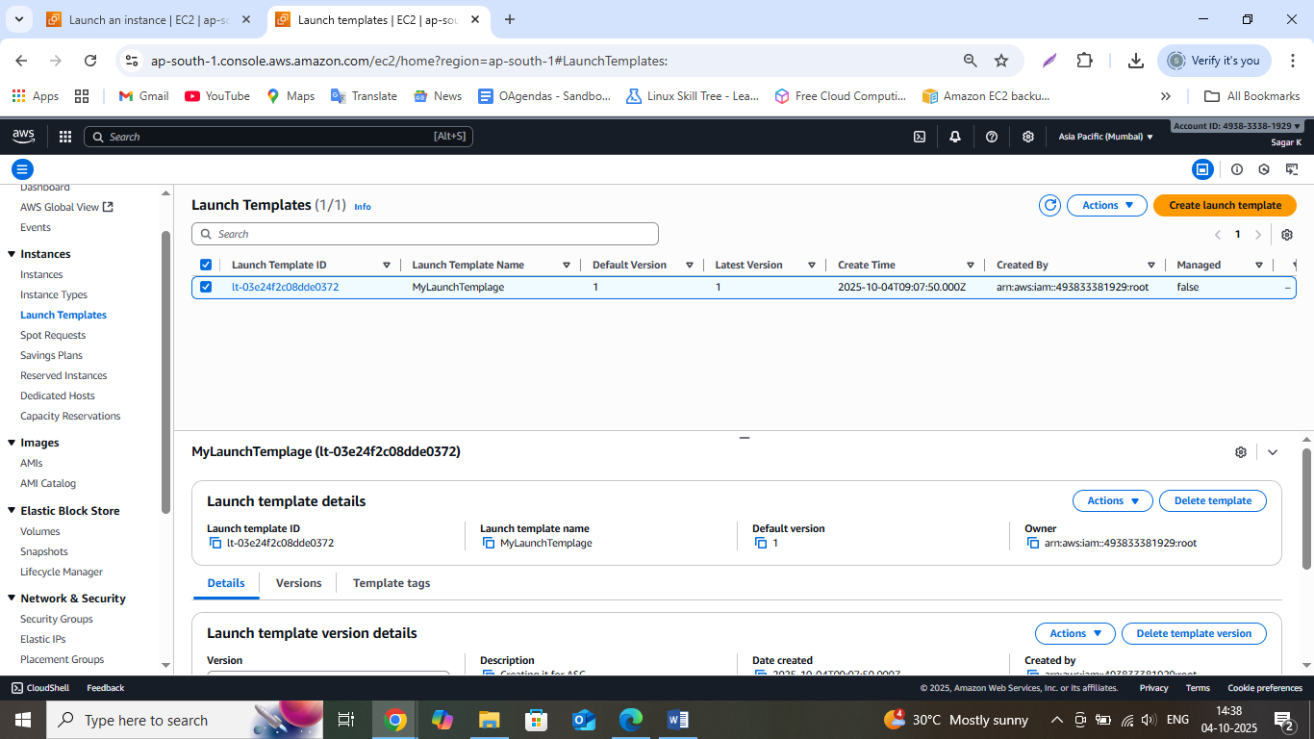

**Now we will create the Auto Scaling Group**

Go to Auto Scaling Groups

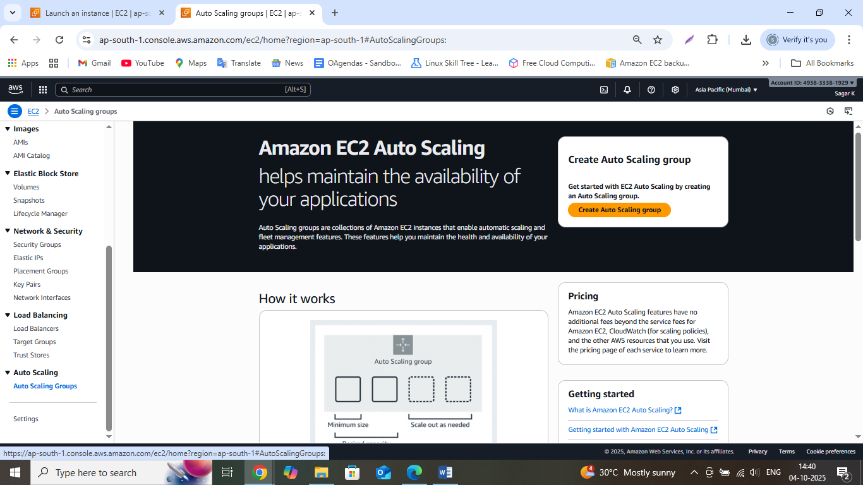

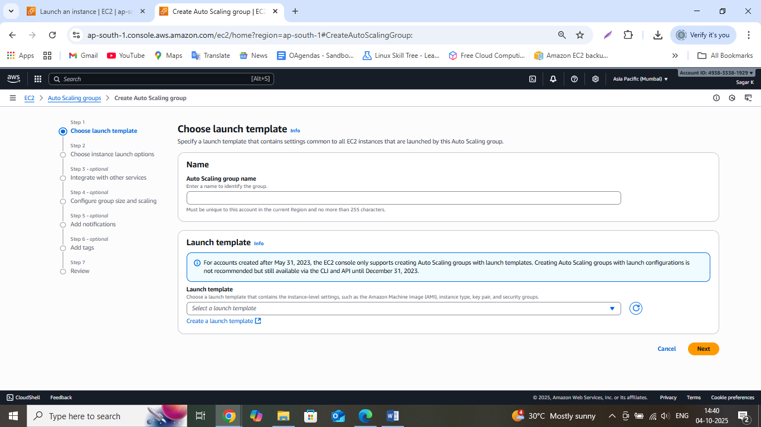

Name the Group and select the Template created by us

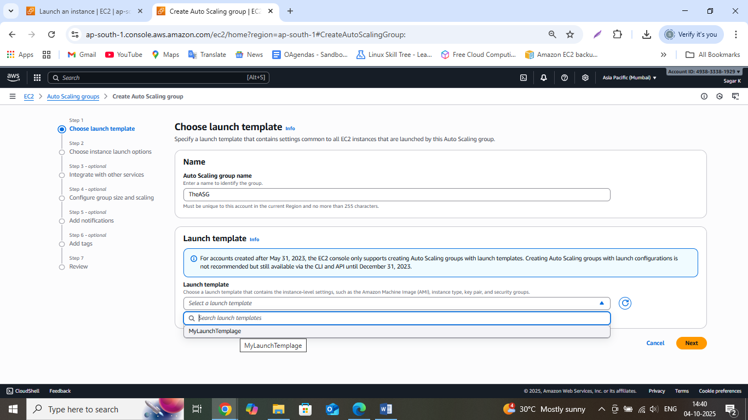

Click on Next



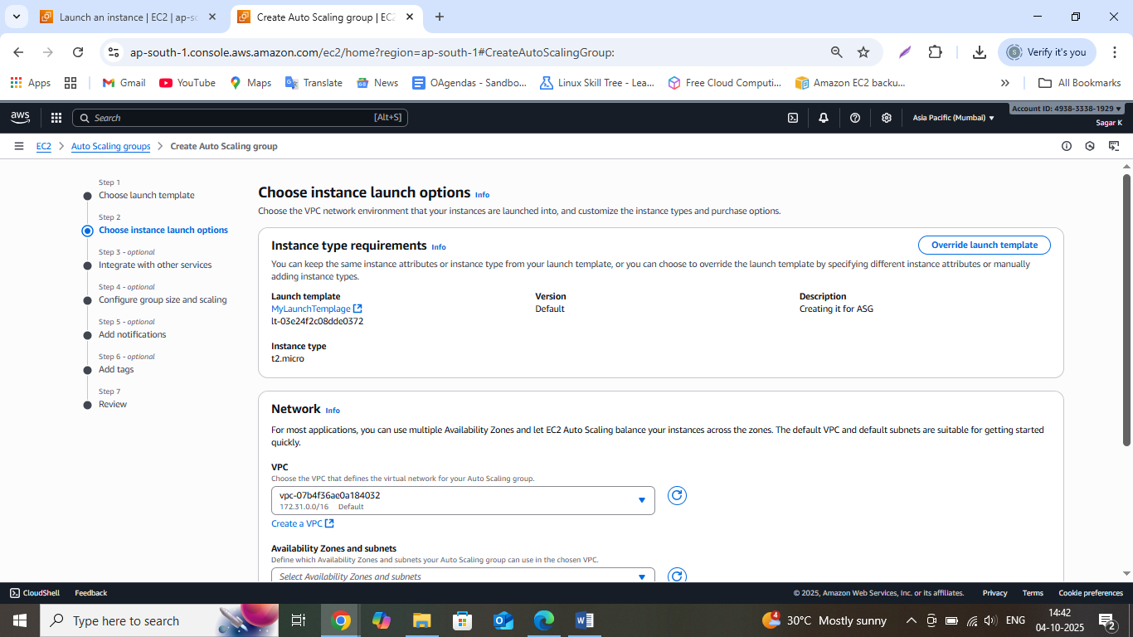

Select 3 availability Zones

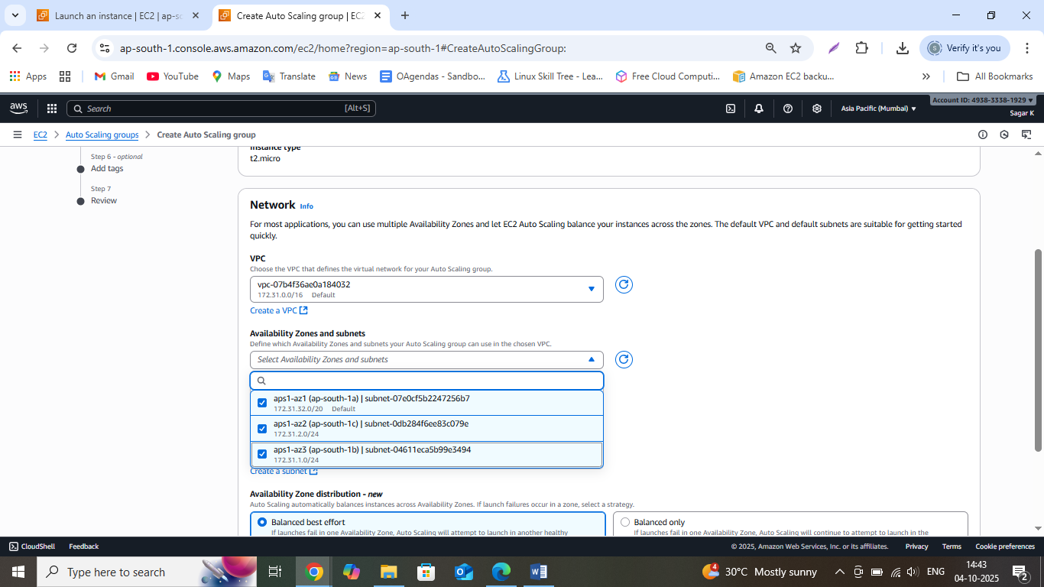

Click on Next and the Integrate with other services screen will appear

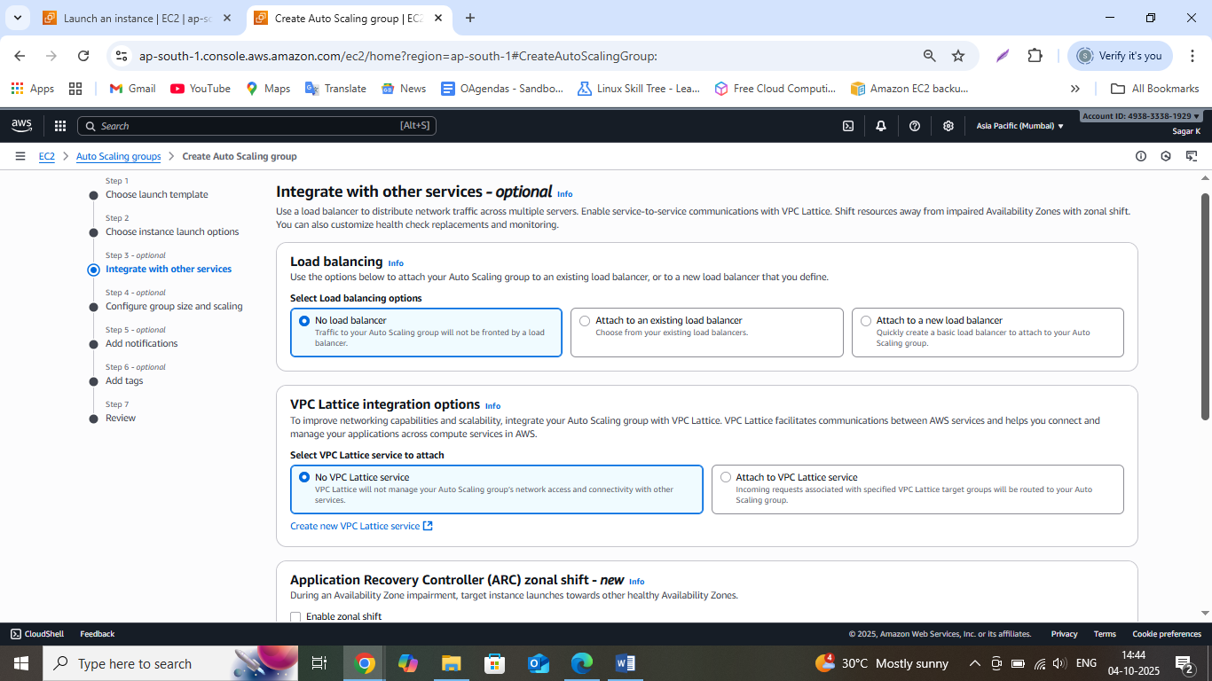

Select the **Turn on Amazon EBS health checks** checkbox

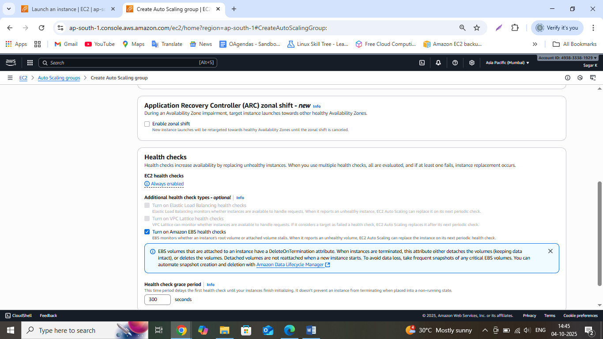

Click on next and Configure Group sizing and scaling will appear

Enter desired capacity as 2, minimum desired capacity as 1 and Maximum desired capacity as 3

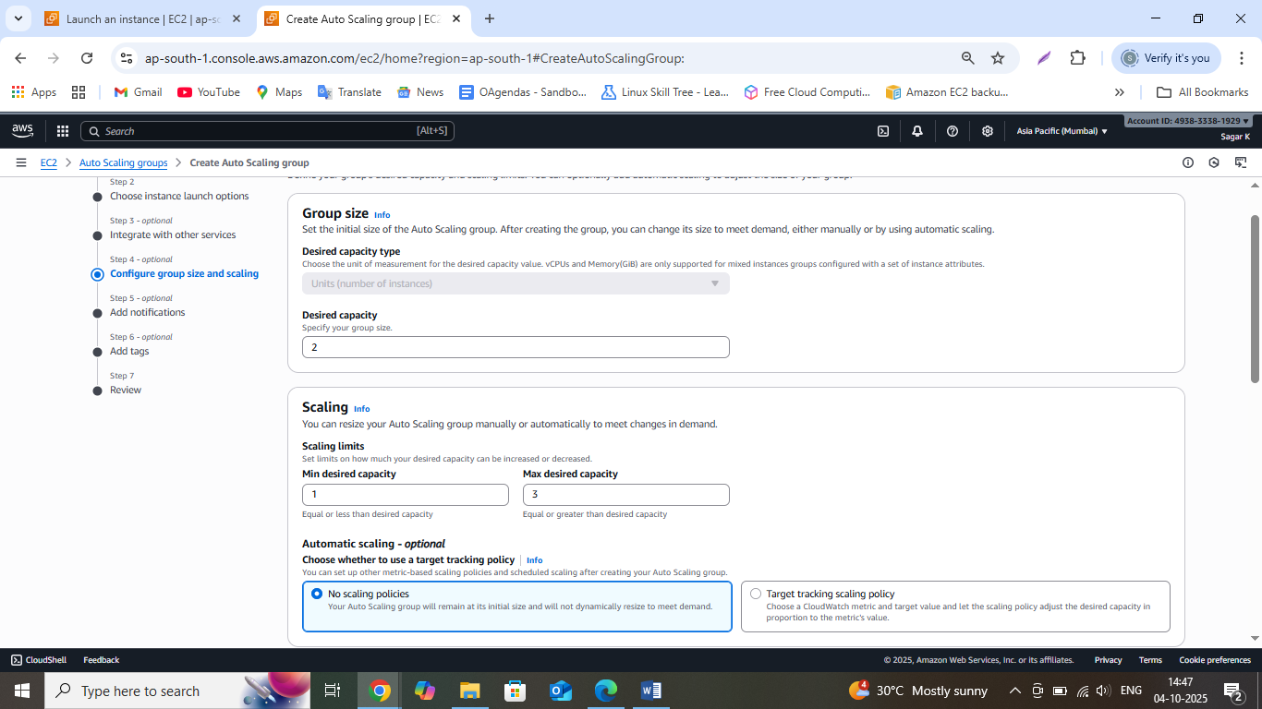

Select Target Tracking scaling policy

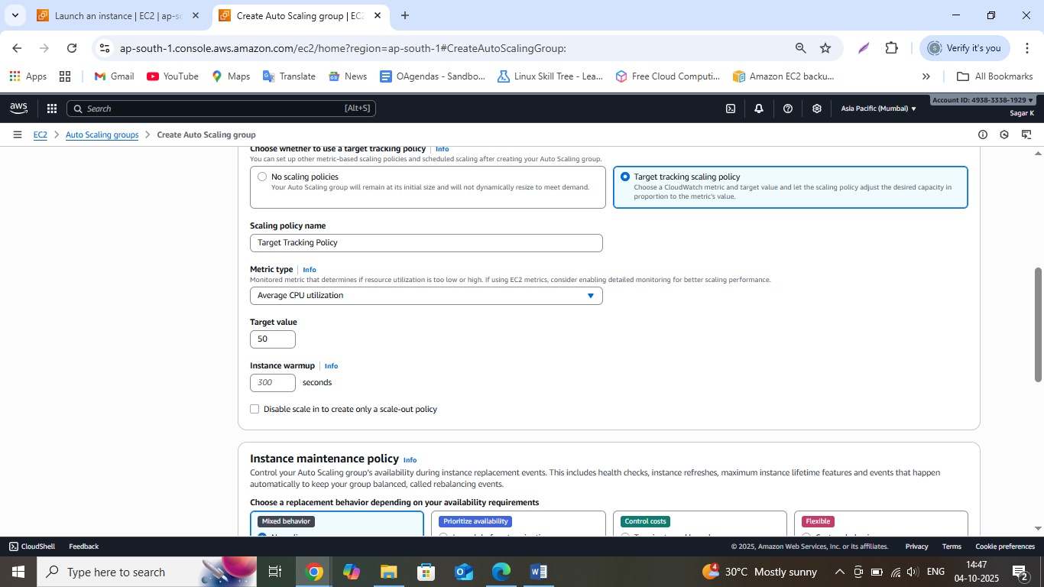

Make Average CPU utilization as 40

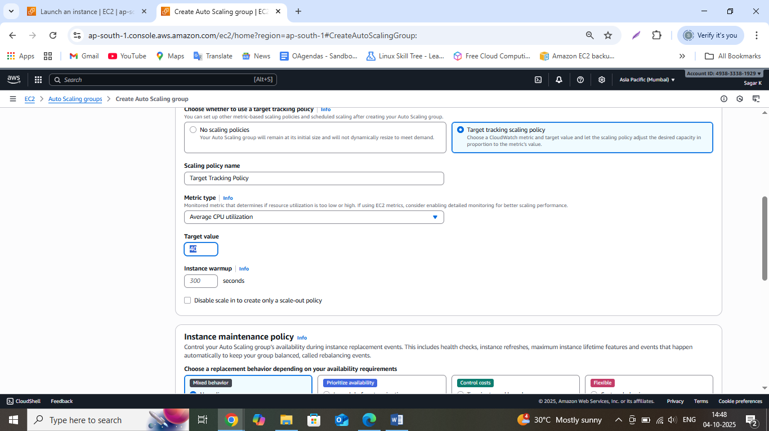

Keep all the other settings as default and click on Next

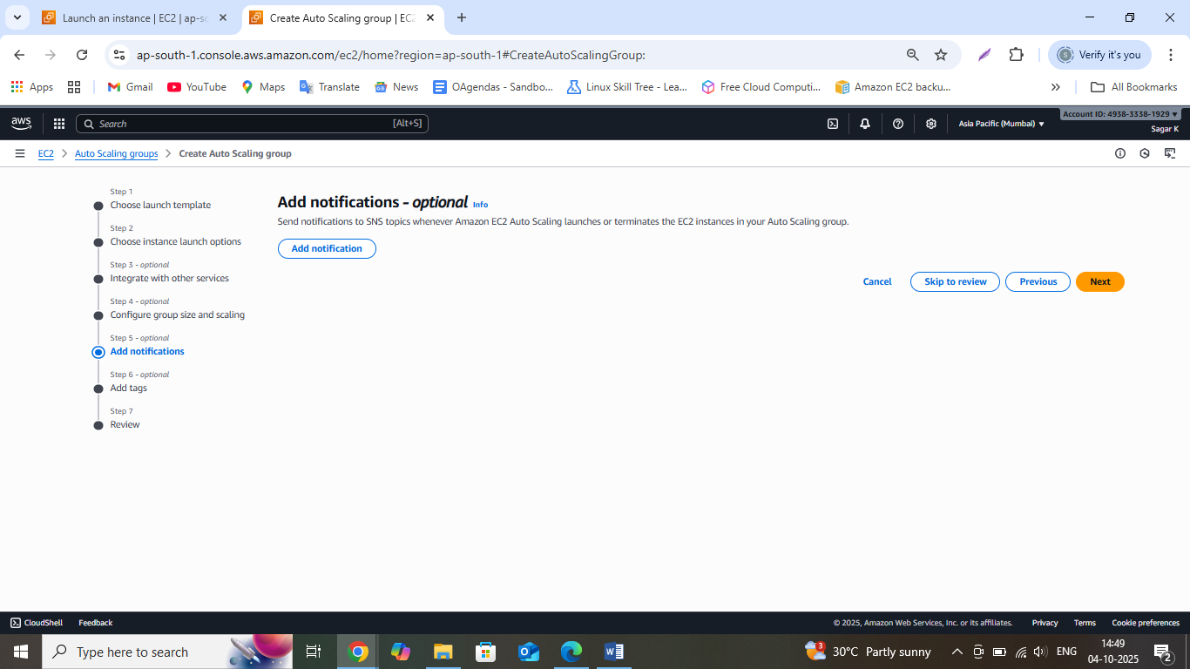

Click on Add notification

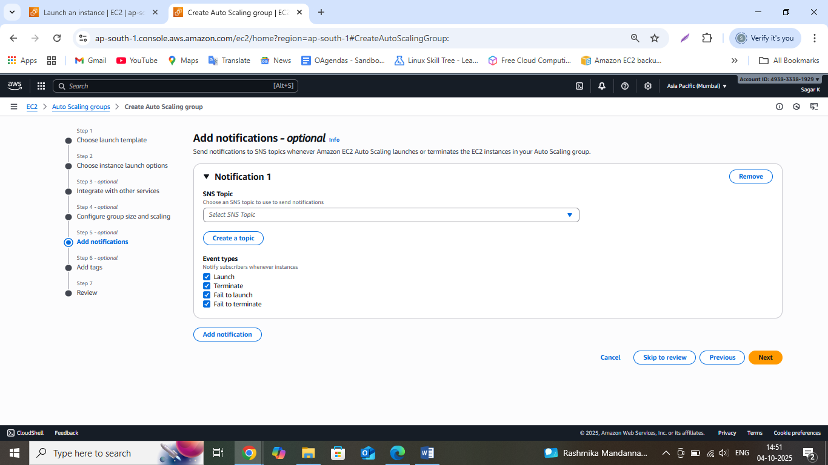

Click on Create Topic

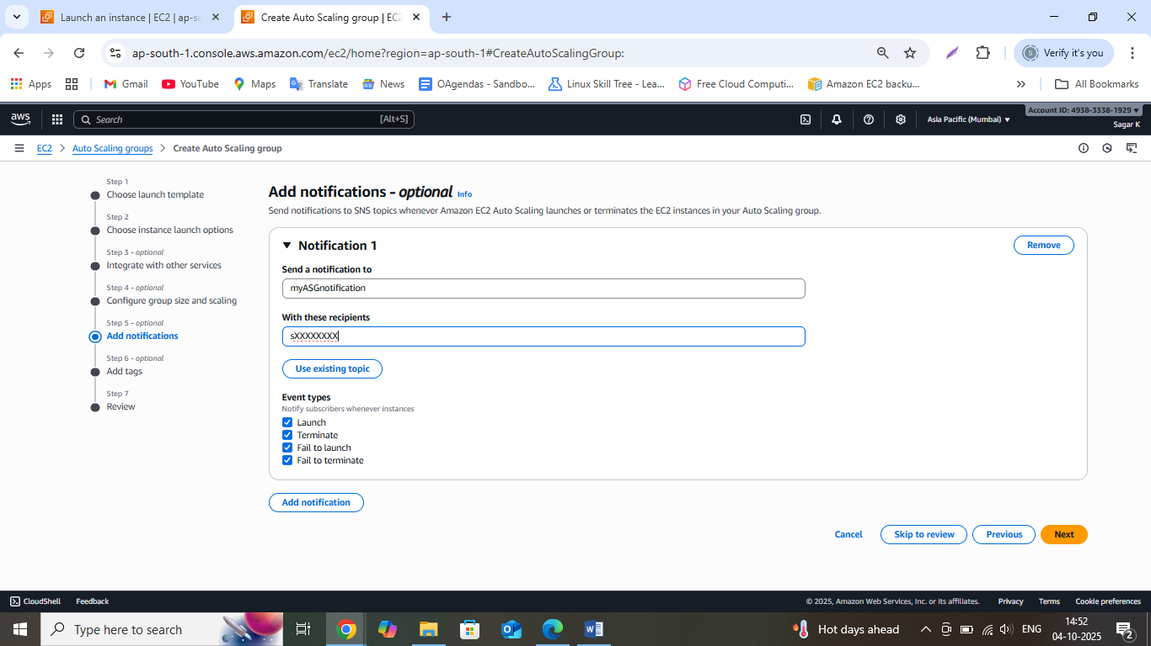

Click on Next

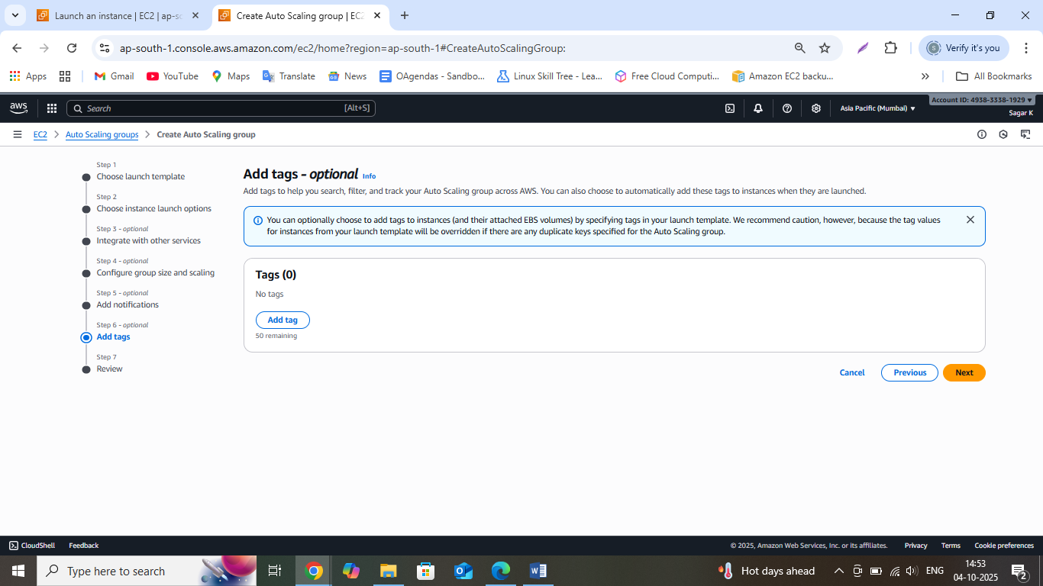

Click on Next

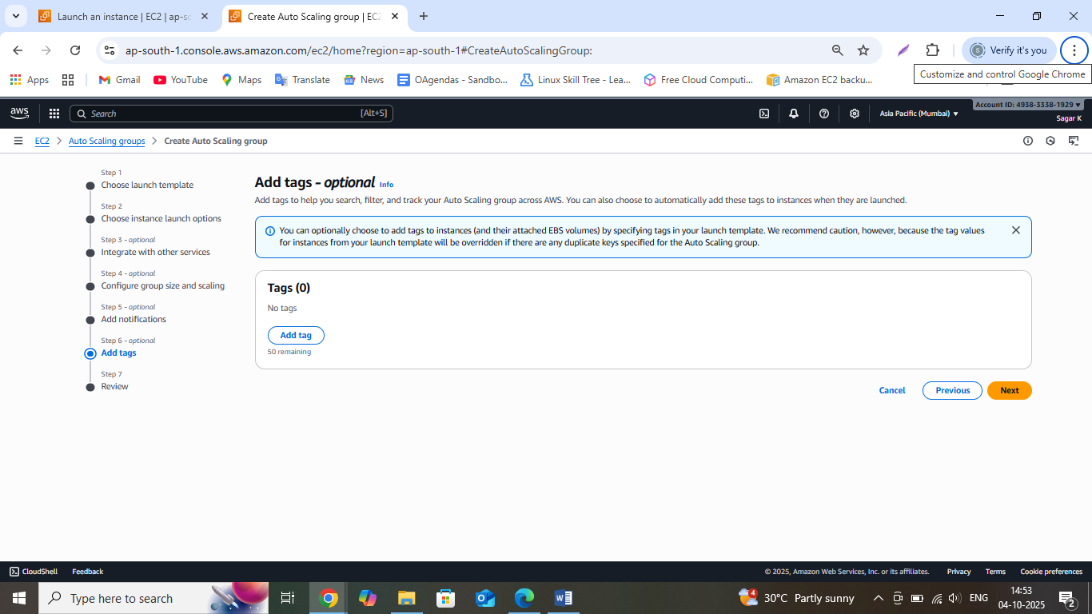

It will show us the details entered by us so that we can review and make the changes if required

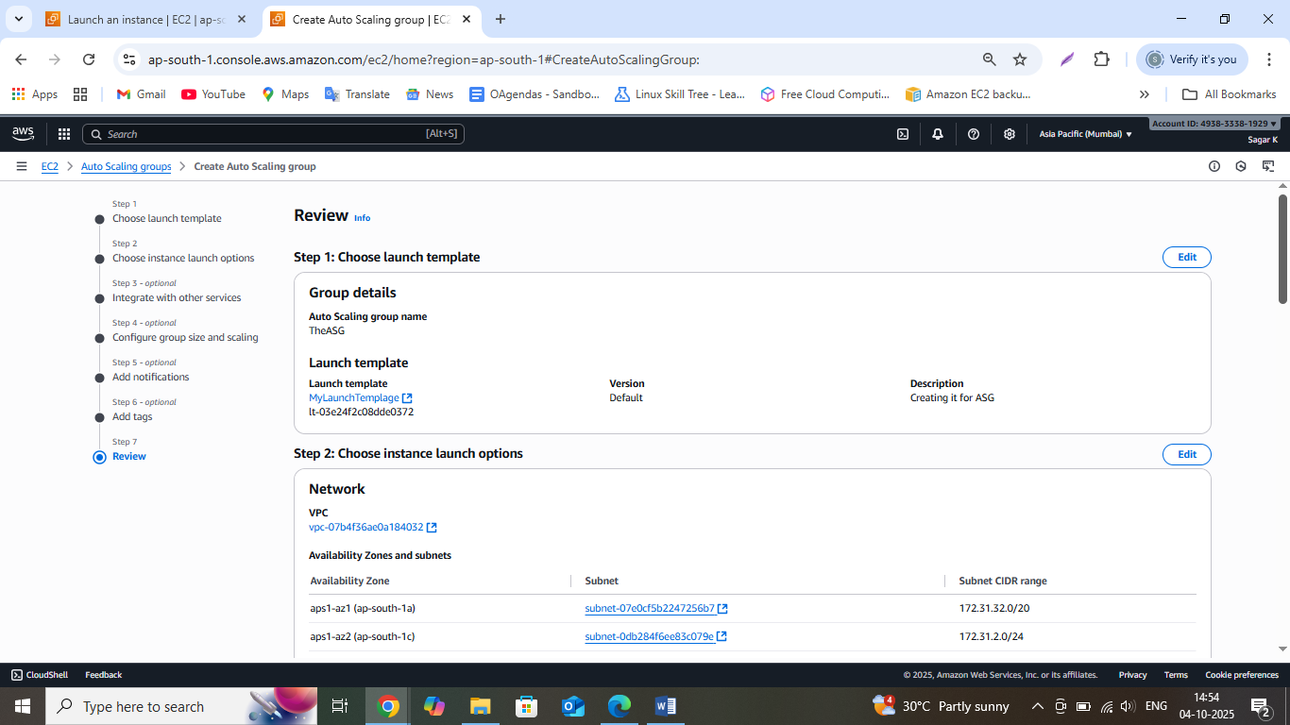

Click on Create Auto scaling group

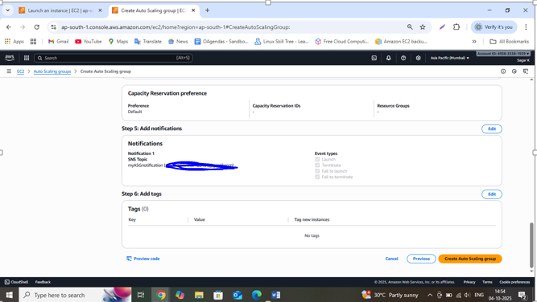

If you check the status you will find that it is updating the capacity

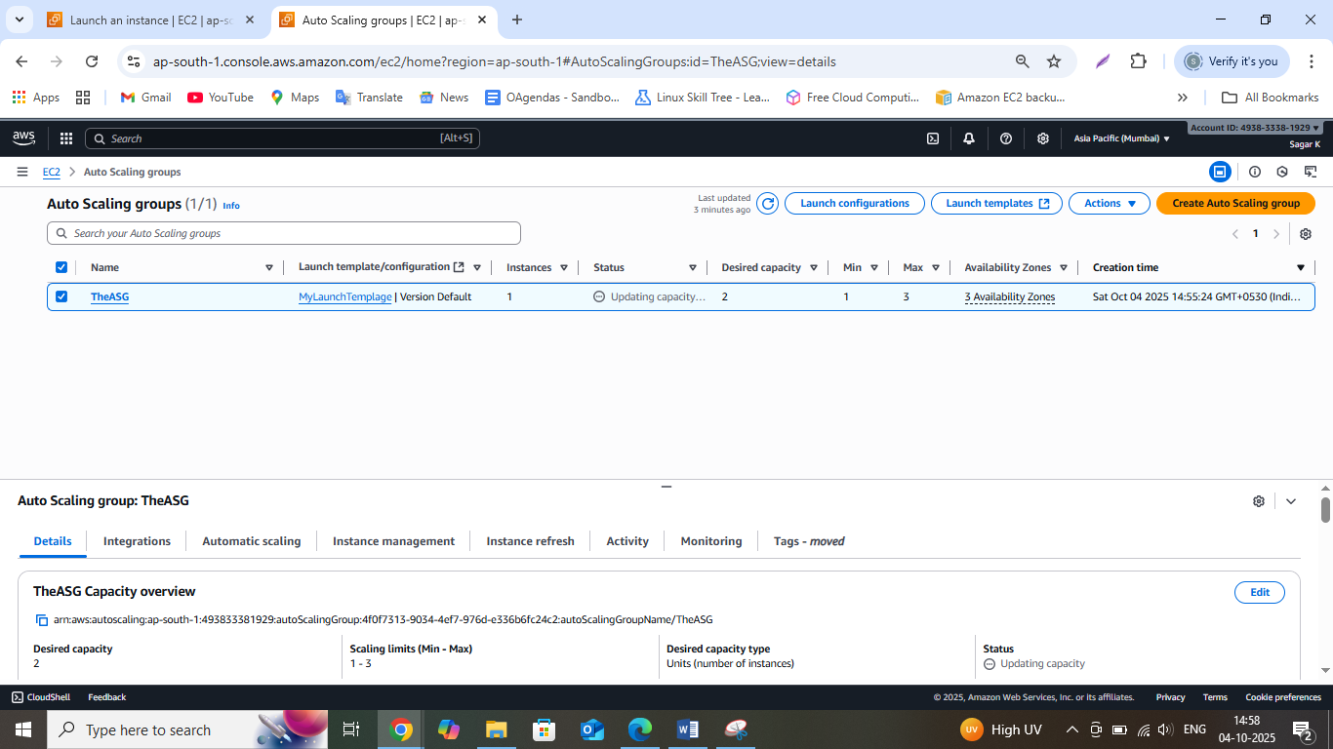

Go to Instances and check the new instance created by ASG, we had stopped our instance hence ASG created the new instances to meet our desired ASG capacity

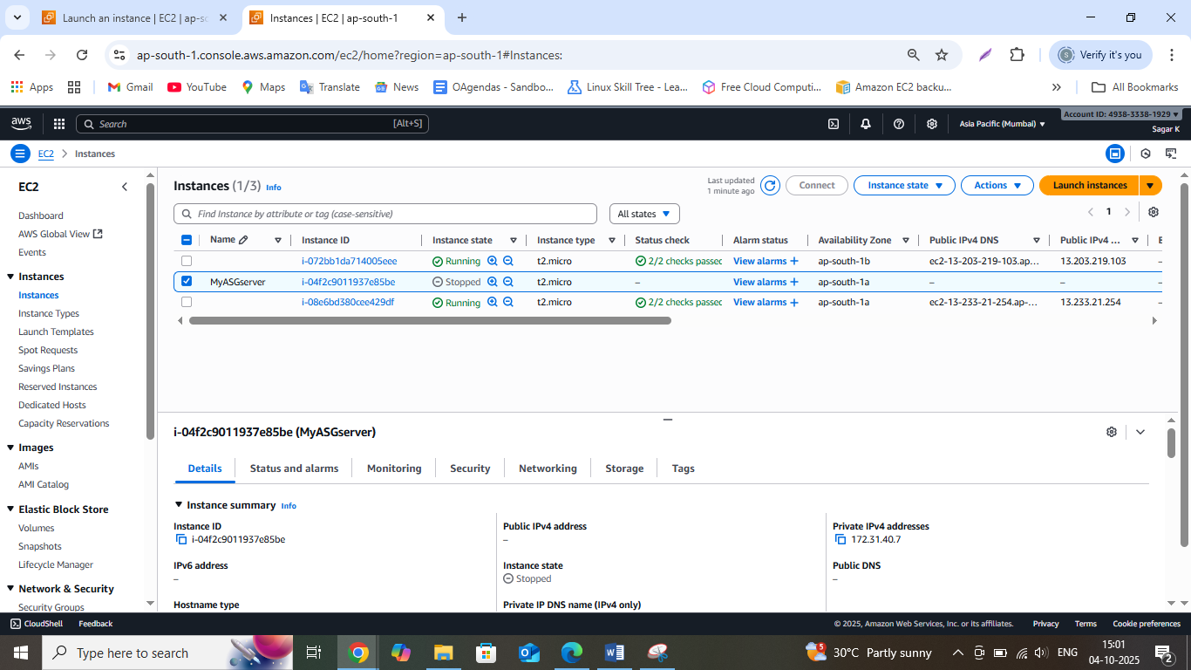

Now select the checkbox of any new instance and copy the public IP address

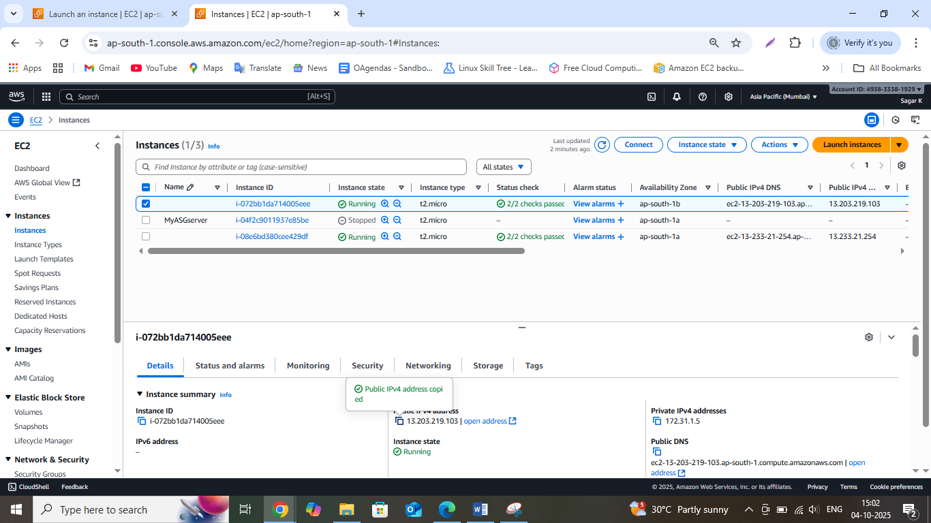

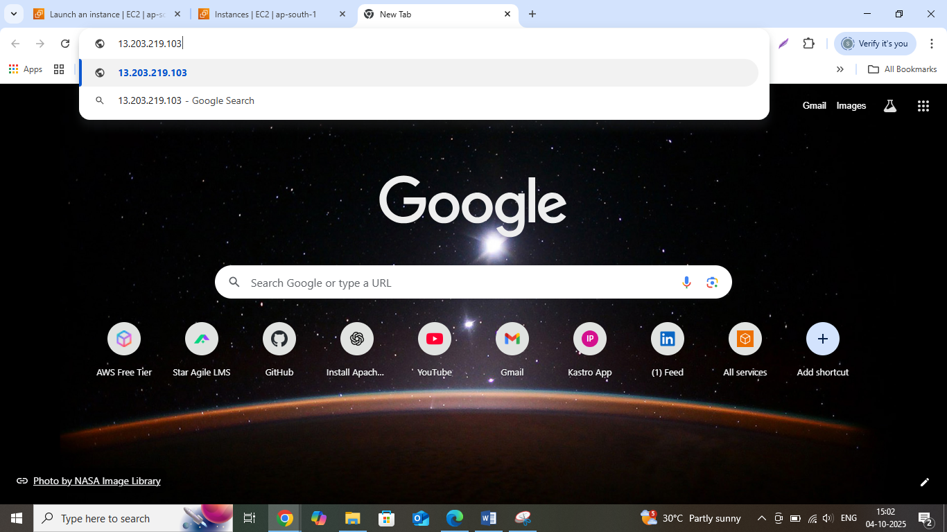

You will find the header which we entered in user data for index.html while creating the Launch template

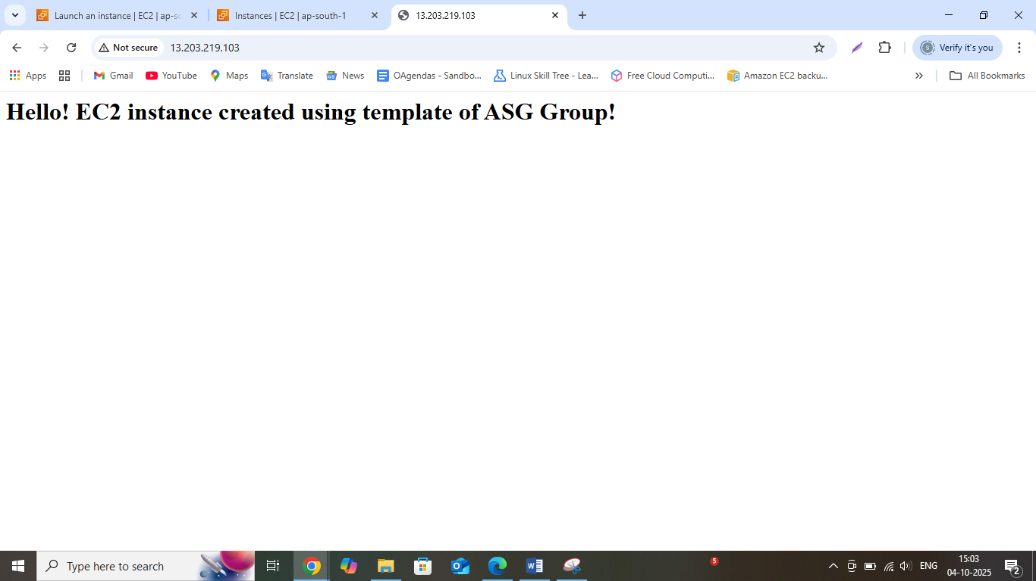

Similarly you can check for the other instance too

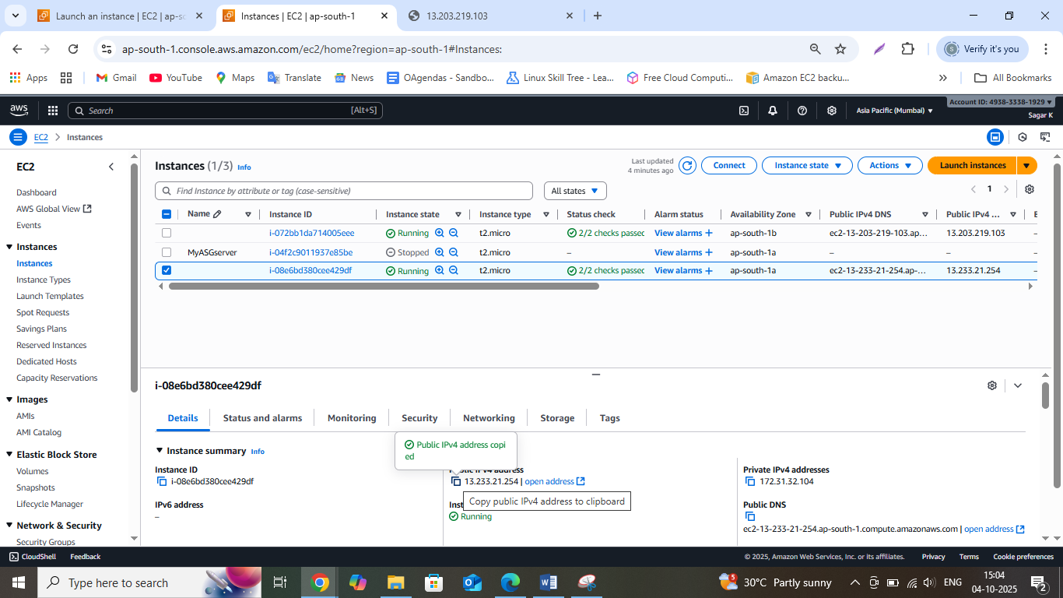

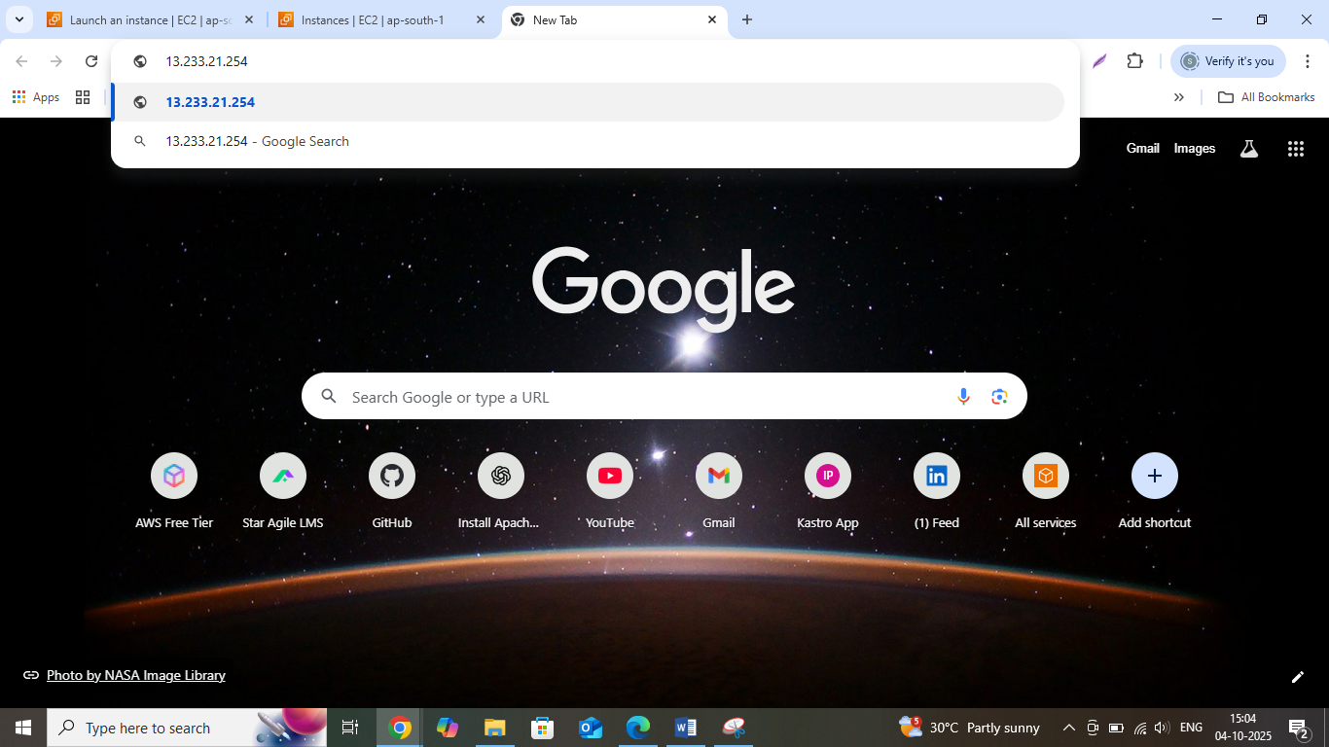

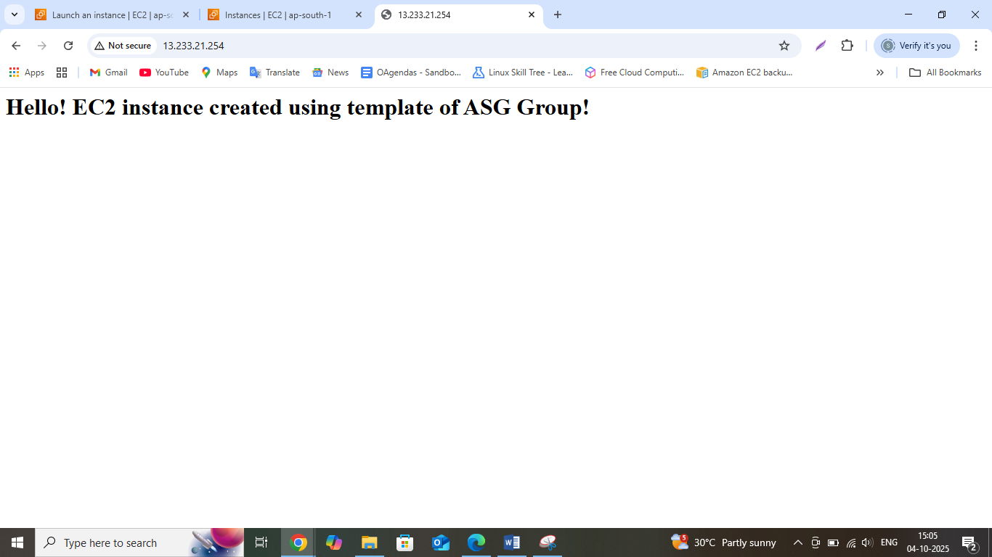

I hope this doc will help you to learn and create the Snap shot, AMI and ASG group very easily.